Enhancing Agents Performance in VizDoom using Reinforcement Learning



Supervisor
Mr. Adil Khan

Submitted by
Shakir Jan
{01-134202-062}
Adnan Musa
{01-134202-113}

Department of Computer Science
Bahria University Islamabad
Table of Contents
1. Introduction: 3
1.1 Project Overview 3
1.2 Project Objective 4
1.3 Problem Description 4
1.4 Proposed Solution 5
1.5 Project Scope 5
1.6 Methodology 5
1.7 Benefits of RL for 3D shooting Games 5
2. Background: 8
2.1 Artificial Neural Network 8
2.2 Convolutional Neural Network 8
2.3 Markov Decision Process (MDP) 8
2.4 Deep Reinforcement Learning 9
2.4.1 On-policy vs Off-policy algorithms 10
2.4.2 Proximal Policy Optimization 10
2.4.3 Advantage Actor-Critic 11
2.4.4 Deep Q Network 12
2.5 VizDoom 12
2.6 Related Works 13
2.7 TABLE REPRESENTATION OF DRL METHODS: 13
3. Literature Review: 13
3.1 Doom AI Competitions 2016 14
3.1.1 Rules of Doom AI competitions 2016 14
3.1.2 Tracks of Doom AI competitions 2016 14
3.2 Doom AI Competitions 2017 15
3.2.1 Rules of Doom AI competitions 2017 15
3.2.2 Tracks of Doom AI competitions 2017 16
3.3 Doom AI Competitions 2018 17
3.3.1 Tracks of Doom AI competition 2018 17
4. Methodology and Experiments 18
4.1 Implementation of PPO Algorithm 19
4.1.1 Mathematical Form 19
4.2 Tools and Technologies used for training agents using PPO. 20
4.3 Implementation of DDDQN (Double Dueling Deep Q-Network) Algorithm 21
4.3.1 Mathematical Form 21
4.4 Tools and Technologies used for training agents using DDDQN. 21
4.5 Implementation of A2C (Advantage Actor Critic) Algorithm 22
4.5.1 Mathematical Form 22
4.6 Tools and Technologies used for training agents using A2C 23
4.7 Inputs for A2C algorithm. 23
4.8 Hyper Parameters for A2C algorithm. 23
a. Gamma: Future reward discount factor. 23
b. Alpha: Actor learning rate. 23
c. Beta: Critical learning rate. 23
d. Action Size: Every action's dimensions. 23
4.9 Environment and Scenarios in VizDoom 23
4.10 Experimental Design and Environment 25
4.11 TABLE II. CONSIDERED HYPERPARAMETERS IN THE EXPERIMENTS 26
5. Results and Comparison: 27
5.1 Defend the Center 27
5.2 Deadly Corridor 34
5.3 Basic Scenario 37
6. Conclusion 42
7. Future Work 43
8. References: 44

Introduction:

Project Overview
The ability of AI agents to make intelligent decisions in diverse and challenging environments is crucial for various applications. This project focuses on enhancing the performance of AI agents within VizDoom, a popular platform that integrates AI with Doom (first-person shooter game) [1]. By training agents to navigate them in different VizDoom scenarios within the Doom game, we aim to demonstrate their adaptability and problem-solving capabilities in different VizDoom scenarios. Through extensive training and evaluation on various VizDoom maps, our agents achieved significant improvement in navigation, decision making, shooting, and enemy combat. This project demonstrates the potential of reinforcement learning in different game scenarios for enhancing AI agent performance.

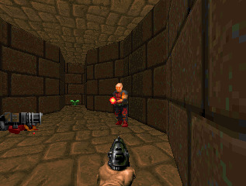
Fig. 1.1. Shows the scenario of a map in VizDoom.

Relevance to Recent Research:
In recent years, there has been a surge in research on deep learning and Reinforcement Learning (RL) applied to the area of video games. The first breakthrough that ignited this surge was when Mnih et al. (2013) [36] presented their deep reinforcement learning model that successfully learned policies directly from raw video data. Today, research is ongoing on all types of video games, ranging from first-person shooters to real-time strategy games (Justesen et al. 2020). One application is that of game testing, where deep reinforcement learning has been shown to increase test coverage (Bergdahl et al. 2021). Another is to create competitive opponents for human players (Khan et al. 2020).

Project Objective
The project aims to significantly improve the performance of AI agents [1] on the VizDoom platform using reinforcement learning algorithms, that include PPO (Proximal Policy Optimization), A2C and DDDQN. The project will focus on performance evaluation of agents, navigating them through various scenarios, avoiding obstacles, and resource management on different scenarios of VizDoom. This project has potential for real world applications, such as intelligent autonomous systems and robotics capabilities, and contributes significantly to AI research by pushing the boundaries of reinforcement learning in complex game environments.

Problem Description
The project addresses the challenge of optimizing the performance of AI agents within the VizDoom platform, a framework that integrates artificial intelligence with the "Doom" video game and training the agent in a way that it should make optimal decisions (movement, ammo preservation and shooting), and learn effectively. Enhancing the agent's capabilities is crucial where intelligent decision-making is paramount.

Proposed Solution
Reinforcement learning algorithm is used to train agents in different scenarios of VizDoom. Scenarios like basic, defend the center, and deadly corridor provide the agents with specific challenges to overcome, and controlled environments for the agents to learn and adapt. Agents’ performance is iteratively optimized by decision-making process through playing each scenario repeatedly. We aim to significantly enhance the agent's performance making it more intelligent, efficient, and better at winning in VizDoom scenarios. We aim to train intelligent agents to navigate diverse scenarios, prioritize ammo conservation, maximize health, and employ strategic combat to master each VizDoom scenario efficiently. By employing reinforcement learning and crafting tailored reward systems, agents are empowered to become resourceful and tactical masters, proving the effectiveness of reinforcement learning in adapting AI that excels in different VizDoom scenario environments.

Project Scope
What is included in the project?
- Implementation of reinforcement learning algorithms to train the agents on existing game scenarios.
- Training of the agents in different VizDoom scenarios to adhere to specific challenges of the VizDoom environment.
- Evaluation of the agent's performance based on its training.
- Analysis of the agent's performance to identify areas for improvement.
Assumptions
- The VizDoom environment is available and working properly.
- The necessary hardware and software resources are available to train and evaluate the agents.
- The agents are capable of learning from their experiences, mistakes and improving agents’ performance over time.
Limitations
- The performance and training of the agents depend upon how efficiently the algorithms are used.
- The agents may not be able to generalize its performance to new and unseen VizDoom scenarios.

Methodology
It employs an experimental approach (agent learning is based on trial and error rather than being explicitly programmed), where agents are trained using PPO algorithm. We have implemented 3 different scenarios (basic, defend the center and deadly corridor) to train the agents in a way that it learns to navigate, anticipate, and attack. It can move around and try different things, like moving left, moving right, attacking, moving forward, moving backward, turning left, and turning right. We have implemented reward shaping to get the desired behavior out of the agents. Data is collected by interacting with the environment. Reinforcement learning algorithms use this data to learn and improve the agent's policy, which maps states to actions. The goal is to maximize cumulative rewards over time, leading to better performance of the agents. Further we have analyzed tensor board charts and have implemented matplotlib graphs to keep track of the important hyperparameters and values that affect the training process leading to a more balanced and effective approach.

Benefits of RL for 3D shooting Games
- Being proficient in complex tasks:
RL is best at learning complex strategies and dealing with dynamic environments, which in turn allows AI agents in FPS games to be expert at skills like flanking, target prioritization and cover related tasks.
- Generalization and adaptability:
These algorithms can adapt to different scenarios, opponent actions, and even weapon configurations without any instructions and this makes it significant for diverse gameplays.

- Emergent behavior:
In FPS games, RL agents have the capacity to astonish their developers with their ability to uncover unforeseen strategies and tactics, resulting in the emergence of more dynamic and inventive AI opponents.
- Potential for competitive AI:
Through continuous research and development, AI driven by reinforcement learning holds the potential to surpass human players in FPS games, introducing increasingly formidable and thrilling virtual adversaries.

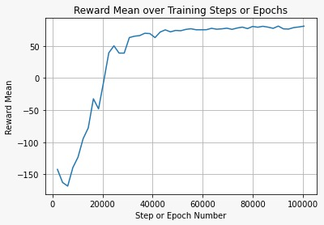
Fig.1.2. Performance of agent in the basic scenario of VizDoom.

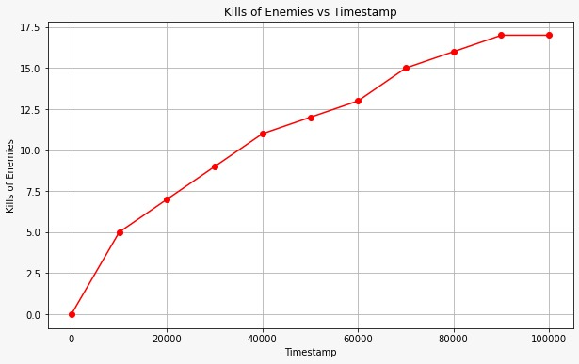
Fig.1.3. Performance of agent using PPO in the defend the center scenario.

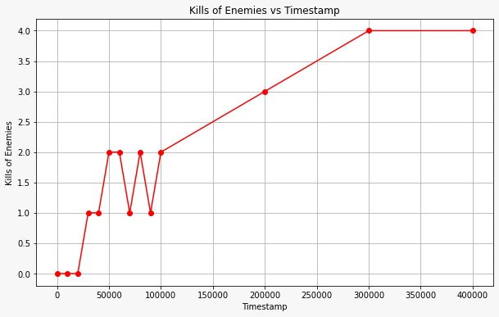
Fig.1.4. Performance of the agent using PPO in deadly corridor scenario.

Background:
This section provides the foundational components utilized in the experimental phase of the study. It encompasses the core principles of reinforcement learning alongside its interconnected neural networks. Furthermore, it provides a concise overview of the three distinct reinforcement learning algorithms employed within the experiment. Additionally, it delves into the concept of hyperparameter optimization and outlines the proposed training environment. Lastly, it explores relevant research studies associated with the subject matter under investigation.

Artificial Neural Network
Artificial Neural Networks (ANNs) are widely utilized structures, drawing inspiration from neurons in the brain. Recent advancements in deep learning encompass ANNs with numerous hidden layers, a characteristic relevant to reinforcement learning. Illustrated in Figure 5.1 is a fundamental feed-forward ANN, where signals propagate solely to neurons in the subsequent layer. Contrarily, a recurrent Neural Network may feature signals moving backward or within the same layer. Each connection within the network is associated with a real value, dictating the activation level of neurons. Activation is determined by a semi-linear combination of input values from the preceding layer [35].

Convolutional Neural Network
A convolutional neural network (CNN) is a category of artificial neural networks comprising multiple layers in deep learning, primarily utilized for image visualization. It stands as one of the most effective and robust tools in handling extensive datasets, particularly in research domains like image recognition [39]. CNNs are widely favored in deep learning, deriving their name from the mathematical operation of convolution between matrices. Comprised of various layers including convolutional, non-linearity, pooling, and fully connected layers, CNNs exhibit remarkable capabilities due to their parameterized convolutional and fully connected layers. Unlike these, the pooling and non-linearity layers do not possess parameters. CNNs present significant advantages in machine learning, particularly for tasks such as image recognition and natural language processing, among various other application domains.

Markov Decision Process (MDP)
The Markov Property dictates that the future is independent of the past, given the present. In other words, the present state encapsulates all relevant information necessary to statistically represent future outcomes.
A Markov Chain consists of a finite set of states (S) and a state probability transition matrix (P), defining the probabilities of transitioning between states.
In a Markov Decision Process (MDP), these elements are combined with the set of actions, rewards, and the discount factor γ. The discount factor γ ∈ [0, 1] reduces the value of future rewards by a factor of γ^kR, where k represents the time steps ahead of the current state. Through these elements, an MDP maps all action-value pairs instead of state-value pairs, creating a comprehensive mapping of which action would yield which value given every possible state in the MDP.
A policy, denoted by π(a|s), dictates which action to take given a state. When this policy takes actions based on expected returns, it is represented as qπ(s, a). Tying this concept together with the fundamental goal of reinforcement learning involves describing the optimal actions to take given the presented state. q∗(s, a) = max qπ(s, a), where q∗ represents the optimal reward given state s and action a.
Thus, an optimal policy can be determined by maximizing the number of q∗(a, s) actions in the policy. π∗(a|s) = (1 if a = argmax q∗(s, a), 0 otherwise).

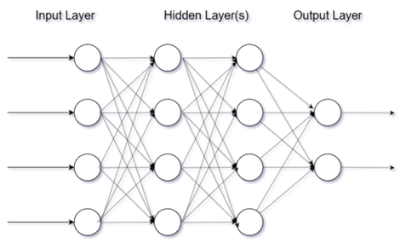
Fig.2.1 Figure showing basic ANN with 2 hidden layer.

2.4 Deep Reinforcement Learning
In machine learning, establishing a strategic approach is essential, with deep reinforcement learning being one prominent method (François-Lavet et al., 2018), alongside supervised and unsupervised learning. Reinforcement learning revolves around enabling an agent to learn through interaction with its environment, where it discerns between actions deemed favorable or unfavorable, with encouragement towards favorable actions.
Through reinforcement learning, an agent accrues experience and leverages it to optimize designated objectives within its environment, facilitated by increasing reward magnitudes. This approach has gained traction in addressing intricate sequential decision-making challenges, evident in environments like chess or contemporary games such as Starcraft 2 (Shao et al., 2019).

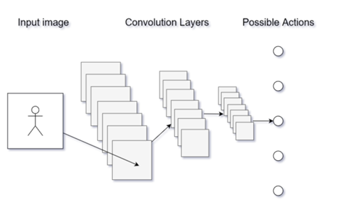
Fig.2.2. Figure showing the basic structure of CNN.
Machine learning furnishes automated methods for pattern detection, subsequently facilitating task execution based on the identified patterns. Deep learning employs neural networks comprising successive layers of nonlinear transformations, each contributing to varying levels of abstraction. The diverse range of neural network layer types in modern applications each possesses distinct advantages, limitations, and applications. Selection of the appropriate type depends on the desired objectives (Lapan, 2018).

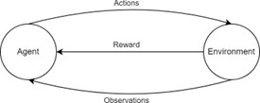
Fig.2.3. Figure showing how the feedback loop works in Deep Reinforcement Learning

2.4.1 On-policy vs Off-policy algorithms
For this study, research is conducted on two on-policy algorithms, A2C and PPO, along with an off-policy algorithm, DQN. On-policy reinforcement algorithms, compared to off-policy algorithms, exhibit higher sampling complexity, while off-policy algorithms pose greater challenges in optimization (Fakoor et al., 2019). Through reinforcement learning techniques, agents can acquire optimized policies based on performance feedback received from their interactions with the environment.
Policies are classified into two types: on-policy and off-policy. In on-policy algorithms, the agent utilizes a batch of data corresponding to its current policy. Conversely, off-policy algorithms leverage data from previous policies to update the current policy.

2.4.2 Proximal Policy Optimization
In the dynamic field of machine learning, continual advancements introduce novel algorithms to address challenges in reinforcement learning. One such relatively recent algorithm is Proximal Policy Optimization (PPO), initially introduced by researchers at OpenAI in 2017 (Schulman et al., 2017). PPO operates as a policy gradient algorithm, oscillating between sampling data from the environment and optimizing an objective function via stochastic gradient ascent. Notably, PPO offers a simpler implementation compared to other policy gradient algorithms like trust region policy optimization.
PPO boasts superior sample complexity when compared to algorithms such as A2C (Advantage Actor-Critic), demonstrating enhanced performance in benchmark environments such as Atari games, striking a balance between sample complexity and implementation ease (Schulman et al., 2017). Training in an on-policy manner, PPO employs a stochastic policy, exploring via sampled actions determined by its most recent policy iteration. Although initially characterized by randomness, PPO gradually mitigates randomness with each update, encouraging the utilization of previously discovered rewards.
The variant of PPO employed in this study utilizes a technique known as clipping. This technique ensures that policy updates do not deviate significantly from prior policies, constraining the objective interval to a narrow range (Schulman et al., 2017). Consequently, the probability ratio is clipped, negating the incentive for the algorithm to stray beyond the objective goal in cases where the objective deteriorates, while disregarding the clipping when improvements are observed.

The pseudo-code found in Algorithm 1 is taken from and elaborated on in Achiam (2020).
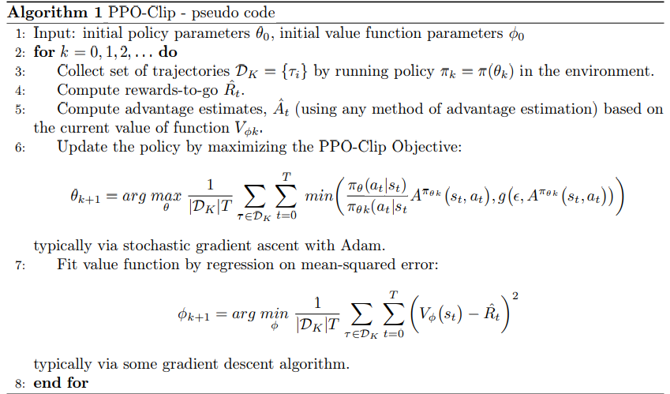

2.4.3 Advantage Actor-Critic
Advantage Actor-Critic (A2C), introduced by OpenAI (Wu et al., 2017), is an asynchronous adaptation of the Asynchronous Advantage Actor-Critic (A3C) algorithm [40] . This approach amalgamates two types of reinforcement learning algorithms: policy-based and value-based. Similar to other actor-critic methods, A2C employs two neural networks—one for the actor and one for the critic. The critic is responsible for estimating the value function, while the actor updates the policy distribution based on the guidance provided by the critic.
The pseudo-code, as depicted in Algorithm 2, is derived from and further elaborated upon in the work by Wang et al. (2018).
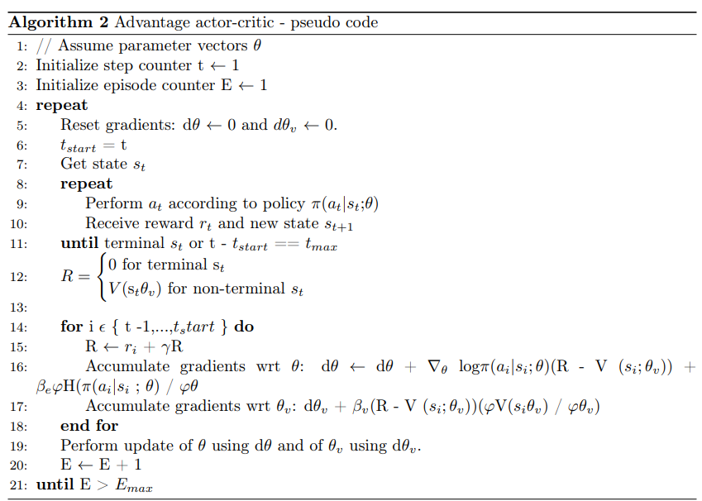

2.4.4 Deep Q Network
Deep Q-Learning, the algorithm behind the Deep Q Network (DQN), stands as a pioneering example in reinforcement learning, capable of tackling complex problems that would typically challenge human capabilities. Initially applied to emulated games from the Atari 2600 console, the method operates within an environment where the state is represented by a 128 RGB pixel frame with dimensions of 210x160. This raw input is preprocessed into grayscale, reduced to 110x84, and cropped to eliminate irrelevant image portions, resulting in a final 84x84 frame .
DQN operates by utilizing a replay memory to store state-action pairs for approximating the expected return and employing an ϵ-greedy policy for action selection. The algorithm begins by initializing the replay buffer, a step demanding considerable system RAM, along with initializing the action-value function with random weights. Subsequently, it selects actions randomly or based on the best current knowledge, initially exhibiting randomness. After executing an action, the resulting reward and state are stored in the replay memory. A batch is then sampled from this memory, and gradient descent is performed on this batch to adjust the weights [36].
The experimental scenario, such as that seen in the Doom environment, mirrors this setup, where the agent's state information consists solely of a frame buffer.
The pseudocode for DQN are found in Algorithm 3 and based off the pseudocode found in [36]

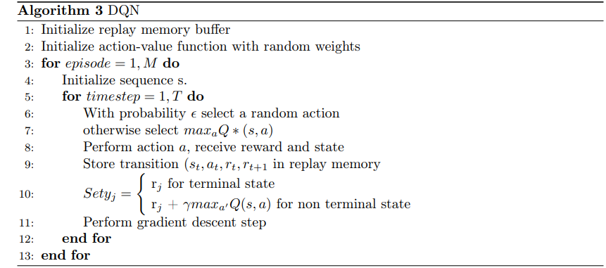

2.5 VizDoom
Introduced in 2016 by Kempka et al., VizDoom emerged as a research platform for reinforcement learning, drawing inspiration from the success achieved in the Atari 2600 domain [36]. Unlike its predecessors, VizDoom exclusively relies on visual input, making it the first first-person shooter environment to adopt such an approach. This design choice offers the advantage of obviating the necessity for researchers and developers to engineer specific features for the agent to learn. Additionally, Doom distinguishes itself with its lightweight and adaptable nature, consuming only 40MB of disk space. Being software-rendered, it can be executed without a desktop environment, facilitating remote operation within a terminal window.
In the years 2016 and 2017, a multiplayer death-match competition served as a platform for further evaluation and testing of visual-based reinforcement learning in intricate environments necessitating concurrent tasks, such as navigation, resource collection, aiming, and opponent evasion (Wydmuch et al., 2019). The competition's outcomes revealed that while the bots demonstrated competence in tactical aspects like aiming and shooting, notable vulnerabilities were apparent, easily exploitable by human players. For instance, the bots' reliance on hard-coded crouching revealed a susceptibility to evade vertical aiming. Furthermore, shortcomings were evident in strategic decision-making areas such as navigation and positioning.

2.6 Related Works
Various environments are available to assess the efficacy of reinforcement learning algorithms, with OpenAI Gym being a prominent choice [41]. Notably, it includes the Atari environment, pivotal in the success of early visually learning reinforcement agents [36]. A more contemporary platform, VizDoom (Kempka et al., 2016), derives from the iconic 1993 video game Doom, presenting intricate 3D environments wherein agents navigate and confront adversaries across diverse scenarios.
Since its inception, VizDoom has served as a key component in numerous research endeavors, primarily utilized for benchmarking different iterations of reinforcement learning algorithms. Notably, in 2016 and 2017, competitions pitted various reinforcement learning agents against each other, with the IntelAct bot, employing a Direct Future Prediction algorithm, emerging as the clear victor, while a DQN-based bot secured second place (Wydmuch et al., 2019).
DQN, alongside A2C and A3C, remains a staple in comparative studies of algorithmic variants. For instance, both were employed in the work of Bakhanova & Makarov (2021), where A3C exhibited markedly superior performance. This study employed a VizDoom scenario dubbed "Defend The Center," placing an agent in the middle of a room with limited ammunition and health. The objective in this scenario is to prolong survival by neutralizing spawning enemies aiming to eliminate the agent. The researchers suggested future investigations should explore the "Deadly Corridor" scenario.

2.7 TABLE REPRESENTATION OF DRL METHODS:

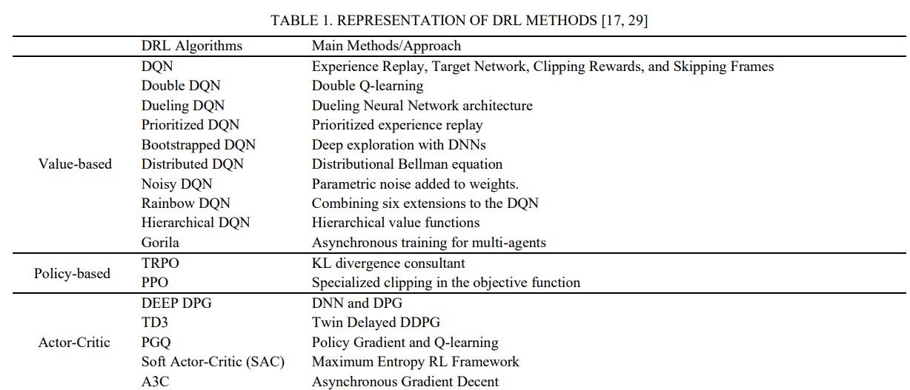

Literature Review:
The early stages of reinforcement learning involved developing a robot's football-playing skills [2][3]. Subsequently, with the introduction of the VizDoom platform, numerous studies emerged focusing on training artificial intelligence agents for playing Doom through reinforcement learning.
VizDoom competitions were held in 2016, 2017 and 2018. The aim of the agents in these competitions was to train agents efficiently for first person shooter (FPS) death match games. The agents had to make efficient decisions based on the visual information of the VizDoom scenarios. To play well, agents need to navigate, visualize the scenarios, explore, and handle the opponent at the same time. The competition's outcomes indicate that while reinforcement learning can create competent agents for playing doom but are not competent to compete against humans.

Doom AI Competitions 2016
The competition's goal was to create an agent that plays a multi-player deathmatch game and tries to score as many frags as possible. According to Doom, a frag is defined as the total number of opponents killed minus the total number of suicides (an agent that ends its life due to damage caused by itself). All the environment's features, including the depth buffer, unique game variables, and Doom's built-in agents, as well as any external resources like custom scenarios, could be used by the competitors to prepare their agents offline. Agents were limited to resources such as remaining health points, ammunition supply and screen buffer information during the competition.

Rules of Doom AI competitions 2016
In the tournament, there were two separate game tracks, and each track consisted of twelve matches, each lasting ten minutes. There was a total of two hours of gaming per track. In every match, an agent started the game, and whenever it got eliminated, it instantly respawned at a randomly chosen respawn site. To make things fair, the respawn site was selected as randomly as possible from among the other players. Also, when a bot respawned, it had special protection for the first two seconds, during which it couldn't be attacked. This setup added an extra layer of strategy and fairness to the competition.

Tracks of Doom AI competitions 2016
- Limited deathmatch on a known map (Track 1)
Each agent had to compete on a single, pre-defined map. The only available weapon for track 1 was a rocket launcher. Most of VizDoom scenarios were somewhat small, allowing players to eliminate opponents by blasting a rocket into a close by wall. It was also comparatively simple to commit suicide. Resources like armor, medikits, and ammunition were shown on the map. A fair match making method was created since the number of participants (9) exceeded the maximum of 8 players per game allowed by VizDoom. Only one agent was eliminated out of all agents. 2 agents who had not performed well in the first 9 matches were not allowed to play in the last three.

Table 1. Results of competition Track 1 2016 [4].
Place | Agents | Frags (F) | Suicides (S) | F/S ratio | Kills | Deaths
1 | F1 | 559 | 38 | 1.35 | 597 | 413
2 | Arnold | 413 | 119 | 1.90 | 532 | 217
3 | Clyde | 393 | 83 | 0.77 | 476 | 509
4 | TUHO | 312 | 112 | 0.67 | 424 | 465
5 | 5vision | 142 | 64 | 0.28 | 206 | 497
6 | Colby Mules | 131 | 91 | 0.25 | 222 | 516
7 | AbyssII | 118 | 99 | 0.21 | 217 | 542
8 | WallDestroyerXxx | -130 | 143 | -0.41 | 13 | 315
9 | Ivomi | -578 | 727 | -0.68 | 149 | 838

- Full death match on unseen maps (Track 2)
Each agent in track 2 had to compete in an unseen map and was initially equipped with a pistol. Compared to Track 1, the scenarios were roomier and included open areas, which increased the importance of precise aim. The scenarios featured a variety of weapons and equipment, including armor, medikits, and ammunition. Every map was created by the authors of the competition.

Table 2. Results of competition Track 2 2016 [4].
Place | Bot | Frags (F) | F/S ratio | Kills | Suicides (S) | Deaths
  M1 | M2 | M3 | T
  113 | 49 | 135 | 297
  76 | 37 | 53 | 167
  51 | 9 | 13 | 73
  8 | 5 | 13 | 26
  12 | 10 | 4 | 26
  6 | 5 | 2 | 13
  2 | 0 | 0 | 2
  M1 | M2 | M3 | T
  19 | 7 | 5 | 41
  2 | 1 | 0 | 3
  7 | 15 | 0 | 22
  1 | 7 | 0 | 8
  3 | 8 | 3 | 4
  2 | 13 | 0 | 15
  0 | 5 | 6 | 11
  M1 | M2 | M3 | T
  47 | 24 | 12 | 83
  3 | 1 | 1 | 5
  31 | 29 | 17 | 77
  60 | 27 | 44 | 129
  45 | 37 | 47 | 131
  69 | 33 | 35 | 137
  48 | 30 | 78 | 156
1 | IntelAct | 256 | 3.08
2 | Arnold | 164 | 32.8
3 | TUHU | 51 | 0.66
4 | ColbyMules | 18 | 0.13
5 | 5vision | 12 | 0.09
6 | Ivomi | -2 | -0.01
7 | WallDestroyerXxx | -9 | -0.06

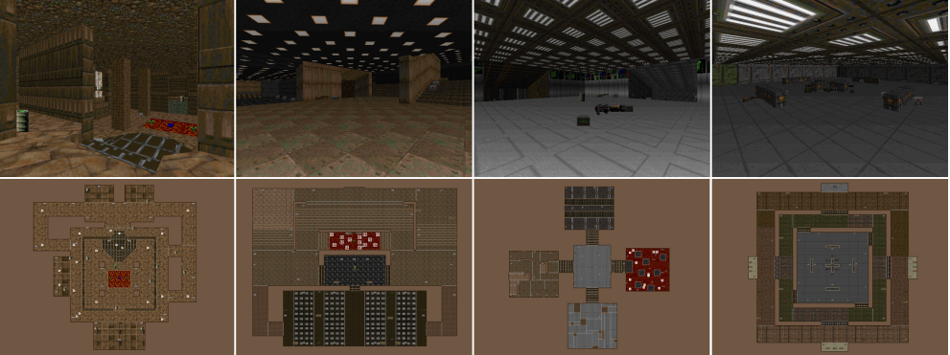
Fig. 5.2. Right 3 shows scenarios used in track 2. Left shows scenario used in track 1.

Doom AI Competitions 2017

Rules of Doom AI competitions 2017
Not much of the rules changed compared to the previous competition. However, a new version of VizDoom (1.1.2) was introduced. The increase in the number of players from 8 to 16 allowed all players to submit to their agents in a single game. Each track consists of 10 matches lasting 10 minutes long. Five new and unseen maps introduced in Track 2, each of which was utilized for two matches. The scenarios were selected at random from a larger list of scenario packs that the Doom community had provided. There were four highly rated Doom multiplayer scenarios, each with several scenarios ranging from 6 to 32 (for a total of 88 maps). As a result, the chosen scenarios were distinguished by their high caliber and careful design. These scenarios were smaller than the ones utilized in the 2016 competitions.

Tracks of Doom AI competitions 2017
- Track 1
In comparison to 2016, the quality of bots that were submitted in 2017 was noticeably higher. Track 1 consist of strong agents interms of their performance. The difference in the number of fragments was not very large, the top agent scored 248 while the lowest agent scored 109. Marvin won the track with 248 frags, which was just 3 more than Arnold2, the runner-up, and 33 more than Axon. The interesting thing is to note that Marvin concentrated on obtaining supplies, such as medikits and armor, which significantly improved his odds of survival, rather than being particularly skilled at hitting targets. Though it was killed the least frequently, Marvin was struck the greatest number of times. However, Arnold2 was more focused at targeting (accurate shooting and detection).

Table 3. Results of competition Track 1 2017 [4]
Place | Agents | Frags (F) | Suicides (S) | F/S ratio | Kills | Deaths
1 | Marvin | 248 | 67 | 1.16 | 315 | 213
2 | Arnold2 | 245 | 69 | 0.84 | 314 | 69
3 | Axon | 215 | 37 | 0.77 | 252 | 37
4 | TBoy | 198 | 31 | 0.60 | 229 | 330
5 | F1 | 164 | 15 | 0.57 | 179 | 290
6 | YanShi | 158 | 88 | 0.58 | 246 | 273
7 | DoomNet | 139 | 40 | 0.50 | 179 | 280
8 | Turmio | 132 | 77 | 0.87 | 209 | 280
9 | AlphaDoom | 109 | 30 | 0.39 | 139 | 281

- Track 2
Since every agent received more than 50 frags, it was able to move, aim, and fire at its opponents. Like Track 1. There wasn’t much of a difference between the first two bots in track 2. Arnold4 took first place in the competition with 275 frags, closely followed by YanShi with 273. Throughout the entire competition, Arnold4 was the most accurate bot and the only one without suicide. This proved to be essential in defeating YanShi, who had the same total number of kills (275) but two suicides. However, YanShi was the greatest agent at avoiding death and had the most detection precision, which allowed him to attain the highest frags/death ratio. IntelAct, the previous competition’s champion of Track 2, came in second place with significantly fewer points (221). It's possible that fewer things on VizDoom scenario in Track 2 caused Marvin to finish lower in fourth place with 193 frags.

Table 4. Results of competition Track 2 2017 [4].
Place | Agents | Frags (F) | F/S ratio | Kills | Suicides (S) | Deaths
  M1 | M2 | M3 | T
  35 | 49 | 50 | 84
  56 | 67 | 55 | 56
  53 | 46 | 51 | 51
  36 | 38 | 52 | 46
  12 | 58 | 26 | 45
  26 | 16 | 33 | 13
  7 | 20 | 9 | 19
  M1 | M2 | M3 | M4 | M5 | T
  0 | 0 | 0 | 0 | 0 | 0
  1 | 1 | 0 | 0 | 0 | 2
  10 | 1 | 6 | 0 | 3 | 20
  4 | 3 | 4 | 0 | 12 | 23
  5 | 2 | 7 | 0 | 3 | 17
  7 | 0 | 0 | 0 | 0 | 7
  4 | 8 | 6 | 0 | 4 | 22
  M1 | M2 | M3 | M4 | M5 | T
  36 | 48 | 42 | 44 | 50 | 220
  28 | 33 | 39 | 40 | 56 | 186
  36 | 48 | 53 | 48 | 62 | 247
  34 | 44 | 39 | 41 | 47 | 195
  46 | 40 | 39 | 41 | 44 | 200
  50 | 48 | 48 | 49 | 47 | 240
  36 | 38 | 42 | 51 | 54 | 221
1 | Arnold4 | 275 | 1.25
2 | Yanshi | 273 | 1.47
3 | IntelAct | 221 | 0.89
4 | Marvin | 193 | 0.99
5 | Turmio | 164 | 0.82
6 | TBoy | 139 | 0.58
7 | DoomNet | 62 | 0.28

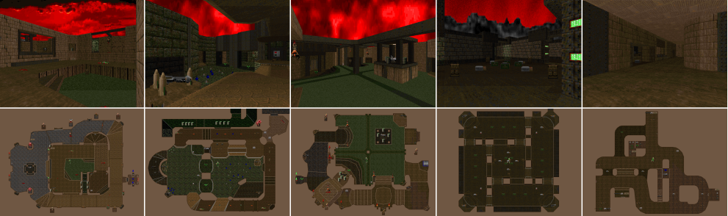
Fig. 6. Scenarios of track 2 of 2017 competition [4].

Doom AI Competitions 2018
The goal was to develop an agent that can complete Doom game levels without the need for auxiliary information by using data that is typically available to human players, primarily visual data. The VizDoom framework, which provides real-time screen access, must be used by the agent. Agents were given the task to beat single player levels as quickly as they can. The entry threshold is minimal because levels change with complexity over time.

Tracks of Doom AI competition 2018
- Track 1
51 teams participated in the 2018 competition and submitted 204 agents out of which the 4 best were selected based on their performance. TSAIL is a reinforcement learning agent that participated in visual doom competition on computational intelligence and games 2018. TSAIL outperformed all other agents in single player mode, where they had to navigate levels and survive for as long as possible with an average completion time of 25.34 minutes. TSAIL consistently completed the single player levels faster than most other agents.
Similarly, Doom Net was another AI agent that played in the competition. Its average competition time was 29.86 minutes across 10 unknown maps. It performed well on maps 2, 5, and 8, achieving an average completion time of 5 minutes. This suggests it excels in efficient map exploration and resource acquisition. Doom Net’s overall performance indicates efficient enemy navigation and resource management. Its performance across varied maps implies an ability to adjust its behavior to different environments and challenges.

Table 5: Results of track 1 Doom AI competition 2018 [27].
Team | Agent | M1 | M2 | M3 | M4 | M5 | M6 | M7 | M8 | M9 | M10 | Total time (m)
TSAIL | TSAIL | 3.90 | 5.00 | 0.72 | 0.34 | 0.82 | 0.32 | 4.06 | 5.00 | 5.00 | 0.20 | 25.34
DoomNet | DoomNet | 0.97 | 5.00 | 0.95 | 1.97 | 5.00 | 0.33 | 5.00 | 5.00 | 5.00 | 0.65 | 29.86
VIPLAB | agent_viplab | 2.45 | 5.00 | 5.00 | 0.87 | 2.42 | 0.48 | 5.00 | 5.00 | 5.00 | 0.33 | 31.54
Ddangelo | DoomGai | 5.00 | 5.00 | 5.00 | 5.00 | 0.65 | 1.00 | 5.00 | 5.00 | 5.00 | 0.68 | 37.33

- Multiplayer Track (Track 2)
The objective was to develop an agent that can participate in Doom deathmatches against other agents based solely on player-accessible data and without the need for any auxiliary information. For the agent to connect to the game, the VizDoom framework must be used. Track 2 is an entire Doom deathmatch on unseen scenarios, much as in past years. Agents will engage in multiplayer competitions, with the winner being the agent who gathers the most fragments. Where the number of frags for this competition is defined as frags = number of killed opponents - number of suicides. 33 teams participated in the 2018 track 2 competition and submitted 152 agents out of which the 3 best were selected from 10 unknown VizDoom scenarios based on maximum frag number.

Table 6: Results of track 1 Doom AI competition 2018 [28].
Team | Agent | M1 | M2 | M3 | M4 | M5 | M6 | M7 | M8 | M9 | M10 | Total frags
Bwbell | Marv2in | 19 | 15 | 53 | 31 | 21 | 51 | 33 | 34 | 32 | 53 | 342
TSAILAB | AWM | 19 | 21 | 30 | 33 | 39 | 27 | 22 | 12 | 19 | 24 | 246
michaelkrax | CVFighter | 26 | 18 | 21 | 21 | 30 | 40 | 16 | 24 | 9 | 29 | 234

Geisler was the first to implement AI in first-person shooter games [5] where a player behavior was modeled in soldier of fortune 2. Bots were tuned using genetic algorithms in counter strike [6]. An algorithm was devised by smith to optimize team tactics in unreal tournament. SARSA was another reinforcement learning algorithm that was part of research in FPS games [7][8]. Continuous and reinforcement learnings were applied to learn the behavior of tanks in the game BZFlag [9].
Reinforcement plays a crucial role in the contribution of efficient algorithms in video games [10][11]. A lot of work is being done to train agents to interact with the environment and outperform human intelligence and achieve superintelligence [12][13]. Superintelligence is being achieved and human intelligence is being outperformed using reinforcement learning [14]. These features are helpful in self-organized systems (like cellular networks) to improve their performance [15].
Reinforcement learning has revolutionized every category of games whether it is classical arcade games [16], real time strategic games [17] and single agent 3D games TORCS [18] to multi agent 3D games like Quake 3 [19]. The process is only possible due to the publicly available research platforms [20][21][22] and competitions [23] that are making a huge contribution in the development of artificial intelligence in games.
VizDoom is a software platform proposed in [24] for research in machine learning that uses raw visual information for learning and reducing the need of high-level information. These platforms provide full control of the environment to train an agent for different situations. These strategies features can also be useful in self-organized systems to improve their performance.

Methodology and Experiments
This section explains how the research was done and gives details about the experiments. The study focuses on comparing different algorithms using the game Doom. In Doom, players see the game from their character's perspective and can move around freely in a 3D environment. They can pick up weapons and health packs and fight against computer-controlled enemies that can attack them. One interesting thing about Doom is that it allows users to create their own custom game scenarios, like designing maps, programming how things work in the environment, and setting specific goals and conditions for winning. First, we will look at the implementation of different algorithms used in our project and then following parts will talk more about the specific scenarios used in the experiments.

Implementation of PPO Algorithm
PPO is a reinforcement learning algorithm that is designed to optimize the policies in reinforcement learning. PPO improves the policies by avoiding large policy updates that lead to catastrophic instability or forgetting. PPO is the derivation of trust region policy optimization (TRPO) algorithm [25]. TRPO decides the size of the optimal step for the upgradation of gradient in an RL algorithm. Quadratic approximation was used to solve the TRPO algorithm but in recent times PPO algorithm is being used to solve problems involving first order approximation.

Mathematical Form

L^{CLIP}(θ)=E_{t}​ [min (π_{θ} (a_{t}​∣s_{t}​) / π_{θ old} (a_{t}​∣s_{t}​) ​A_{t}^{GAE}​, clip(1−ϵ,1+ϵ) A_{t}^{GAE}​)]

Explanation
- Policy π_{θ}:
In π_{θ} (a_{t}​∣s_{t}​) a_{t} is the probability of taking action in the state s_{t} under the parameterized policy parameters θ.
- Old policy:
In π_{θ old} (a_{t}​∣s_{t}​) a_{t} is the probability of taking action in the state s_{t} under old policy. It is used to calculate the ratio between probabilities in the objective function.
- Advantage A_{t}^{GAE}​:
A_{t}^{GAE}​ is an estimate of the advantage function can be found at the generalized advantage estimation. It calculates the benefit of taking action a_{t} in state s_{t} in relation to the average benefit in that state. It aids in lowering the policy gradient estimate's variance.
- Objective Function:
L^{CLIP}(θ) is the objective function that is used to maximize the reward and limit the policy updates. It is used to prevent significant policy changes by encouraging new policies to be like the old ones.
- Clip Function:
The policy update's size is constrained by the clip function. It is employed to make sure that there are no significant changes to the policy in between updates, avoiding significant oscillations that can cause instability.
- Expectation E_{t}:
An expected sequence of events, actions, and rewards is assumed. The expectation is estimated by the algorithm using samples from several trajectories.
The probability ratio r_{t}(θ) = (π_{θ} (a_{t}​∣s_{t}​) / π_{θ old} (a_{t}​∣s_{t}​) can be represented as follows.
L^{CPI} (θ) = E_{t}​ [ (π_{θ} (a_{t}​∣s_{t}​) / π_{θ old} (a_{t}​∣s_{t}​) ​A_{t}^{GAE}​]
L^{CPI} (θ) = E_{t} [r_{t}(θ)​A_{t}]
The conservative policy iteration is denoted by the superscript CPI. Maximizing L^{CPI} without a restriction would result in a large policy update, therefore, we are now considering modifying the objective. The following is the primary goal we suggest.
L^{CLIP}(θ) = E_{t}​ [min (r_{t}(θ) A_{t} ​, clip (r_{t}(θ), (1−ϵ,1+ϵ) A_{t}​)]
Here epsilon (ϵ) is the hyperparameter that is tuned based on the scenario and controls the size of the policy update. L^{CPI} is the initial term inside min. By clipping the probability ratio, second term clip (r_{t}(θ), (1−ϵ,1+ϵ) A_{t} adjusts the surrogate aim and eliminates the motivation for shifting r_{t} out of the interval [1 - ϵ,1 + ϵ]. The goal is the lower bound or a pessimistic bound, on the unclipped objective since take the minimum of the clipped and unclipped objective. Under this technique, we only incorporate the change in probability ratio when it makes the objective worse and we ignore it otherwise [29].

Tools and Technologies used for training agents using PPO.
- VizDoom:
The primary environment for training and assessing the reinforcement learning agents is VizDoom. It offers a framework for building situations and recreating the Doom first-person shooter game world.
- Open Gym:
The VizDoom environment used to train reinforcement learning agents can be interacted via OpenAI Gym.
It makes it simpler to test out various reinforcement learning algorithms by offering a consistent method for defining environments, acting in them, and monitoring their states and rewards.
Agents interact with the VizDoom environment through initializing the environment, taking actions and receiving rewards.
- Stable Baselines:
Proximal Policy Optimization (PPO) and other reinforcement learning algorithms are implemented in PyTorch using Stable Baselines3.
This library makes it simpler to test out different algorithms and evaluate how well they perform by offering high-quality implementations of a variety of reinforcement learning methods.
- PyTorch:
Since PyTorch is the foundation of Stable Baselines, we have worked directly with PyTorch to define unique elements of the models or to alter pre-existing algorithms.
Defining and training neural network models quickly is made possible with PyTorch, which is essential for deep reinforcement learning algorithms such as PPO.
- Matplotlib:
We have used Matplotlib to analyze the performance of the reinforcement learning agents and have visualized the current state of the game.
To see how the agent is adapting to the VizDoom environment and learning new skills, we have used Matplotlib to plot a variety of graphs, including training progress, awards the agent has received over time, kills and any other pertinent data.
- Git:
Git is utilized for version control, mostly for cloning the VizDoom repository and handling codebase changes.
Git is used to engage with team members, log changes, try out new strategies, and go back to earlier iterations when needed.
Git version control makes ensuring that the codebase of the project is manageable, well-organized, and simple for us to share and replicate.

Our project has incorporated these technologies to produce a thorough framework for testing and training reinforcement learning agents within the VizDoom setting. They give us the tools we need to define environments, put algorithms into practice, train models, see the outcomes visually, and manage code effectively.

Implementation of DDDQN (Double Dueling Deep Q-Network) Algorithm
DDDQN is an extension of DQN algorithm that has the properties of both DQN and double Q-learning. Dueling deep Q-learning introduces a novel network architecture consisting of two streams. One estimates the state-value function V(s) and outputs a scalar, while the other estimates the action advantage function {A (s, a); a ∈ A} and outputs a vector of size representing the number of possible actions. The outputs from the two streams are then aggregated (in a specific way) to produce the Q-values {Q (s, a); a ∈ A}. While the advantage stream calculates the benefit of acting at a particular state, the value stream allows us to estimate state values because there are some states that are indifferent to all possible actions (no action leads to an improved predicted cumulative reward). Thus, the advantage is Q (s, a) = A (s, a) + V (s) [30].
There are two distinct estimations in the dueling DQN, and they are as follows:
- An agent’s perceived usefulness in a particular state is estimated using this measure of state value.
- Calculate the benefit of each action in each state [31].

Mathematical Form
Two Q-value functions and the Q-learning update algorithm form the foundation of the mathematical description of DDDQN.
Q (s, a; α, β) = V (s; θ, β) + [ A (a, s; θ, α) – 1/|A| ∑ ā A (ā, θ, α)]
The two components of Q-network include a value stream (V (s; θ, β)) and an advantage system A (a, s; θ,α)). Here
- Q (s, a; θ, α, β) is the estimated Q-value for state s and action a.
- V (s; θ, β) is the value of state s.
- A (a, s; θ, α) is the advantage of taking action a in state s.
- θ represents the parameters of the shared layers.
- α represents the parameters of the advantage stream layers.
- β represents the parameters of the value stream layers.
- ∣A∣ is the number of possible actions.

Tools and Technologies used for training agents using DDDQN.
The following tools and technologies were used for implementation of DDDQN algorithm.
- PyTorch:
PyTorch is an effective deep learning framework for creating and refining neural network models.
- Tensor board:
Tensor board is a package that allows to log and visualize training metrics so that Tensor board can analyze them.
- VizDoom:
Platform for training agents in different scenarios with different complexity levels.
- State:
The agent uses the game screen's raw pixel inputs as states. To get motion data, these states are stacked and preprocessed.
- Actions:
The scenario defines a collection of possible actions that the agent can take, represented as a vector.

- Reward:
The environment bestows awards on the agent in accordance with its deeds and the status of the game.

Hyperparameters:
- Learning Rate (lr):
The pace at which the optimizer is used to change the model's parameters during training.
- Discount Factor (gamma):
In the Q-learning update equation, the discount factor is used for future rewards. The parameters that control the agent's exploration strategy begin with a high level of exploration and gradually decreases are called exploration parameters (explore start, explore stop, decay rate).
- Memory Size:
The capacity of the experience replay buffer, which is used to hold historical data for training purposes.
The quantity of experiences taken from the replay buffer for every training iteration is known as the batch size.
- Total Episodes:
The number of training episodes is the total number of episodes that were used to train the agent.
- Pretraining Episodes:
The total number of firsthand encounters that are added to the replay buffer prior to training. The number of frames to repeat an action on is called the frame skip. The number of episodes after which the model weights are saved is known as the frequency of model saving.

Using a DDDQN model, the offered code teaches an agent how to play Doom. It communicates with the gaming environment, preprocesses state, chooses actions according to the model's projected Q-values, and double Q-learning and experience replay are used to update the model's parameters. Tensor board is used to visualize the training progress as a variety of hyperparameters are adjusted to optimize the training process.

Implementation of A2C (Advantage Actor Critic) Algorithm
A2C is a reinforcement learning algorithm that combines the properties of both policy gradient methods and value function methods. A2C is the synchronous version of A3C policy gradient method. A2C stabilizes learning by substituting the advantage function for the Action value function as the Critic. The Advantage function is supposed to determine how much better an action is taken at a state in comparison to the average value of the state.

Mathematical Form
L(θ) = ∑_{t=0}^{T} ​(logπ _{θ}​(a_{t​}∣s_{t}​) ⋅ δ_{t} ​+ β ⋅ H (π _{θ} ​( a_{t​}∣s_{t} ​)) − α⋅V^{πθ}​(s_{t}​))
- s_{t}​: State at time t.
- a_{t}​: Action taken at time t.
- r_{t}​: Reward received at time t.
- π_{θ}​(at​∣st​): Policy, i.e., the probability of taking action at​ given state st​ and parameterized by θ.
- V^{πθ}​(st​): Value function, estimating the expected return starting from state st​ following policy π_{θ}.
- θ_{t}​: Advantage function, representing the advantage of taking action at​ in state st​ over the average action value in that state.
- γ: Discount factor for future rewards.

Tools and Technologies used for training agents using A2C
Apart from using PyTorch, VizDoom, OpenCV, and matplotlib, additional technologies are used.
- NumPy:
NumPy is used to manipulate arrays and perform numerical computations.
- Random:
The creation of random numbers is handled by the random module.
For image processing activities like frame preprocessing, OpenCV (cv2) is utilized.
- Collections:
A window of scores is maintained using the data structure from the collection’s module.

Inputs for A2C algorithm.
- Input shape:
The size of every state in the environment (C, H, and W).
- Action size:
Every action's dimensions.
- Seed:
For reproducibility, use a random seed.
- Device:
Selects between using the CPU and the GPU.
- Gamma:
Future reward discount factor.
- Alpha:
The actor (policy) network's learning rate.
- Beta:
The critical (value) network's learning rate.

Hyper Parameters for A2C algorithm.

Gamma: Future reward discount factor.

Alpha: Actor learning rate.

Beta: Critical learning rate.

Action Size: Every action's dimensions.

Environment and Scenarios in VizDoom
This section talks about the different situations used to test the agents. It gives some basic information about each scenario, like how rewards are given, what the agents are supposed to do, and how they can reach their goals. It also includes details like the size of the game screen, how often frames are skipped, and screenshots for each scenario.
- Basic Scenario
In a basic scenario an agent has the properties of attacking, moving right and left. Ammo is the available game variable in the scenario. Agent is placed in a room with a single enemy.
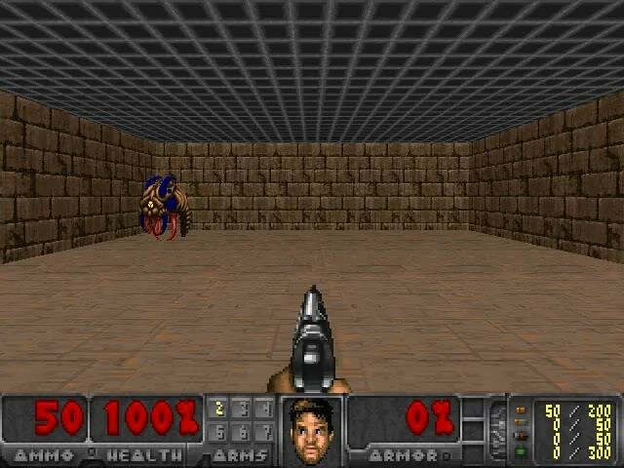
Fig. 7. Scenario of basic in VizDoom.

- Deadly Corridor Scenario
In the scenario of deadly corridor an agent has the properties of moving left, moving right, attacking, moving forward, backward, turning left, and right. Health and ammo are the available game variables of the scenario. The main aim of this scenario is to reach the goal (the vest). The vest is placed at the opposite end of the room. Agent appears in a room with a total of 6 enemies at left and right [26].

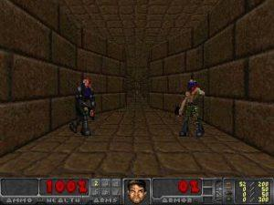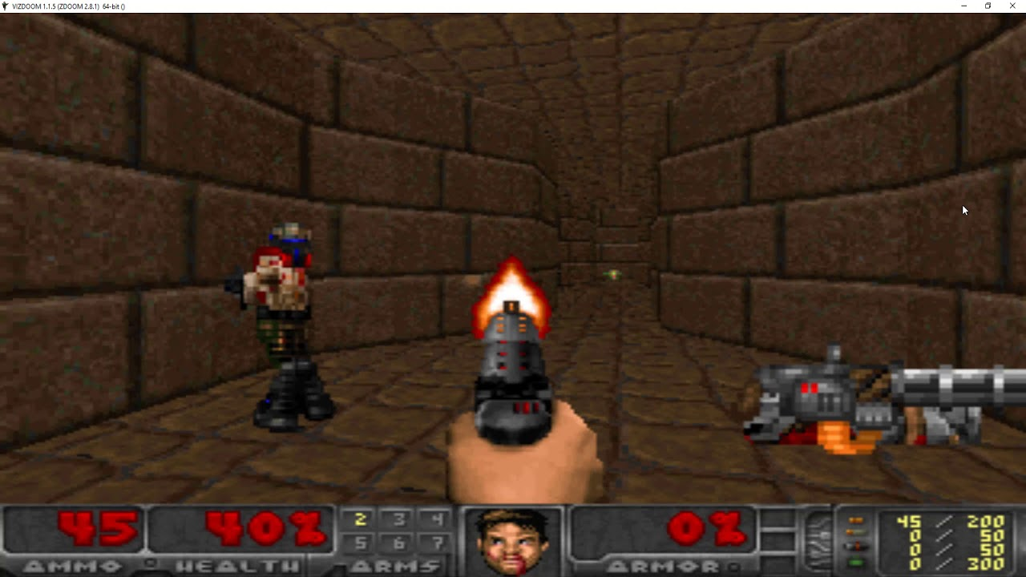
Fig. 8. Starting position of the agent. Fig. 9. Agent killing the opponent.

- Defend the center Scenario.
In this scenario, shown in Figure 10, there's a central agent armed with a gun and limited ammunition. The agent can only turn and shoot left or right. Around the central agent, there are five enemies coming from different directions. When the agent kills one enemy, another one immediately appears. The goal for the agent is to kill as many enemies as possible. Each enemy killed gives the agent a reward of +1, but if the agent gets killed, it receives a penalty of -1. However, because the agent doesn't have much ammo, it's possible for the agent to get killed. Although using reward shaping has been proven to improve agent performance in other cases, it's decided not to use it in this scenario.

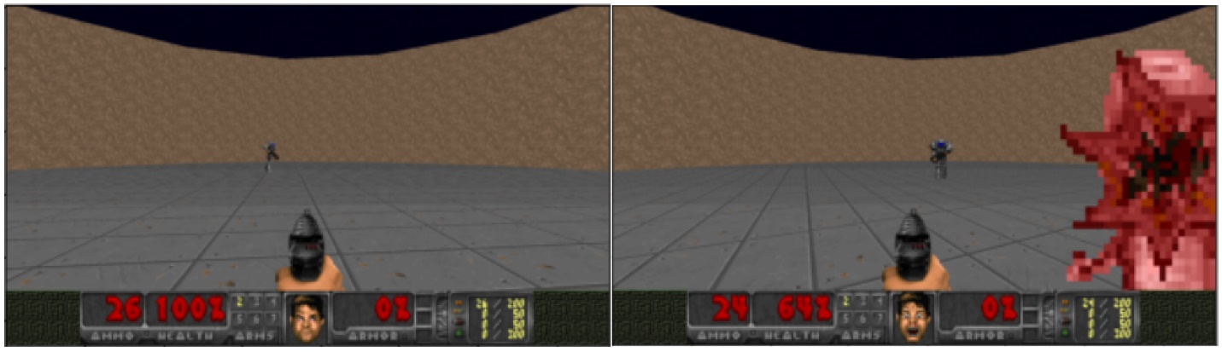
Fig. 10. Scenario of Defend the Center in VizDoom.

Experimental Design and Environment
This section delineates the experimental configuration and hyperparameters (see Table II) utilized for training and assessing the agents. A batch size of 32 and a sequence length of 4 are designated. Preceding the commencement of training iterations, adjustments are applied to the weights of the target networks. Throughout the training phase, the parameter Epsilon initiates at a value of 1.0 and progressively diminishes after each training step until it converges to 0.0001 towards the conclusion. Following a specified number of steps, the agents are subjected to testing with Epsilon set to 0.01, and the average episode reward across 100 episodes is graphically represented.
A memory buffer with a capacity of 60,000 is employed, with only consecutive observation sequences drawn from the memory, and the final observation serving as a terminal point. This adaptation is particularly significant in scenarios such as health-gathering, effectively mitigating considerable negative rewards should the agent expire during the last observation.
Periodically, adjustments are enacted to augment training, encompassing augmentations to the batch size and sequence length, set respectively to 64 and 8. While the preceding four experiences are harnessed for training, the initial four serve to update the agent’s memory. The interval preceding memory sampling is extended to 15 steps, and the number of gradient steps is elevated to 8000. Furthermore, the learning rate is attenuated to 0.0001 to refine the training process. These refinements are geared towards bolstering the training efficacy and efficacy of the agents across diverse scenarios.

The entire implementation is executed utilizing PyCharm 2021 Professional version, ViZDoom, TensorFlow [40], Keras [41], OpenCV [42], CMake, GCC, and Python 3.6 (64-bit) on a Windows 10 64-bit Operating System equipped with Intel(R) Core(TM) i3-6100U CPU @ 2.30GHz 2.30 GHz and NVIDIA GTX 1070 GPU with 8.00 GB RAM (DDR) and 256 GB SSD. The algorithms undergo iterations ranging from thousands to millions of steps, executing actions, optimizing, and adapting the networks accordingly.

TABLE II. CONSIDERED HYPERPARAMETERS IN THE EXPERIMENTS

Parameters | A2C | PPO | DDDQN
Discount Factor | 0.99 | 0.99 | 0.99
Learning Rates Range | 0.0001 to 0.025 | 0.0001 to 0.025 | 0.0001 to 0.025
Experience | 60k | 60k | 60k
Screen Buffer | 640, 480 | 640, 480 | 640, 480
Batch Size | 32 | 32 | 32
Initial Decay | 1.0 | 1.0 | 1.0
Final Decay | 0.0001 | 0.0001 | 0.0001
History Length | 4 | 4 | 4
Frames per Action | 4 | 4 | 4
Time Elapsed (Hours) | 50 | 72 | 70

- Data Collection and Reward Shaping.
Data collection forms a critical component of agent training process as it really lays the foundation for the agent to get acquainted with its environment and subsequently learn and improve its performance over the course of time. The major steps in data collection include Environment interaction, State representation, Action execution, Feedback signal and Experience replay buffer.
- Environment Interaction: It refers to the interplay between agent action and its observation as the agent takes any action in the environment. Basically, the agent just receives different observations in return letting it know the outcome of its doings.
- State Representation:
State refers to the compiled form of observations that is not limited to visual information, but also includes sensory information and any relevant features that the agent can receive at any given moment.
- Action Execution:
Based on the present state of the environment, the agent selects the most suitable action that is then executed in the game leading to the shift of the environment to a new state.
- Feedback (Reward Signal):
Depending on the action taken by the agent, the agent receives feedback in the form of a reward that fluctuates in value, motivating or demotivating the agent to take the action in the future. For example, successfully hitting a target may yield a positive reward, while taking damage could result in a negative reward.
- Experience Replay Buffer:
The experiences (state, action, reward) are stored in a buffer for the agent to learn from a diverse track record than just to close-down on the result of the immediate action. This approach improves the efficiency of learning in the long run.

- Reward Shaping:
- Definition of Rewards:
It is basically the indicator or value that is used as a form of feedback by the agent to know the consequence of its action.
- Encouraging Desired Actions and Discouraging Undesired Actions:
By molding the reward function equation in a way that motivates the agent to take certain actions, we manipulate those ways. For example, in a reward function reward = kill count * 1200 + delta ammo* = -0.5, we are motivating the agent to eliminate more enemies by giving kill count a larger positive value while demotivating to lose delta ammo by giving ammo a negative value.

Results and Comparison:
In each scenario, reinforcement learning algorithms evaluate how well the agent is performing using metrics like remaining ammunition, enemy kills, overall score, and average health. These metrics are tracked throughout training episodes, providing a continuous assessment of the agent's progress. After each training step, the objective is to attain the desired outcomes. To effectively demonstrate the performance of each agent, their results are visualized individually. This approach enables a clear comprehension of variations among agents and facilitates comparisons between different models.

Defend the Center
The agent’s performances trained on the defend the center scenario are shown in this subsection, along with their learning curves.
Fig. 11. Kill Counts on Defend the Center scenario using PPO.

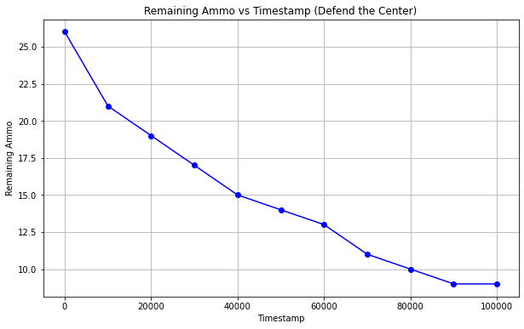
Fig. 12. Ammo left on Defend the Center scenario using PPO.

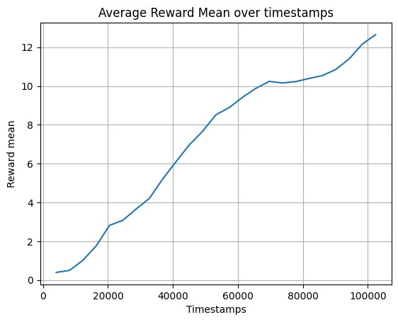
Fig 13. Agent’s reward Mean on Defend the Center scenario using PPO.

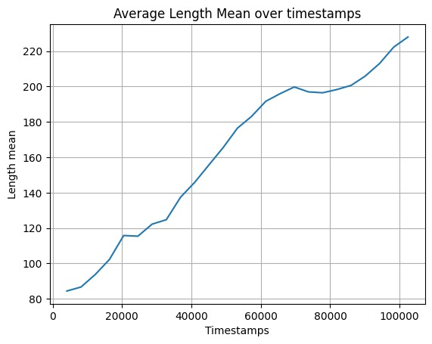
Fig 14. Average episode length during training using PPO in defend the center scenario.

The agent trained with DDQN demonstrated above-average performance, achieving satisfactory scores in the given scenario. Notably, the agent excelled in terms of both overall kill counts and ammo preservation. Additionally, the agent effectively maintained its health at an average level of approximately 85%, as supported by the data presented in Fig. 15, Fig.16, Fig.17, Fig.18.

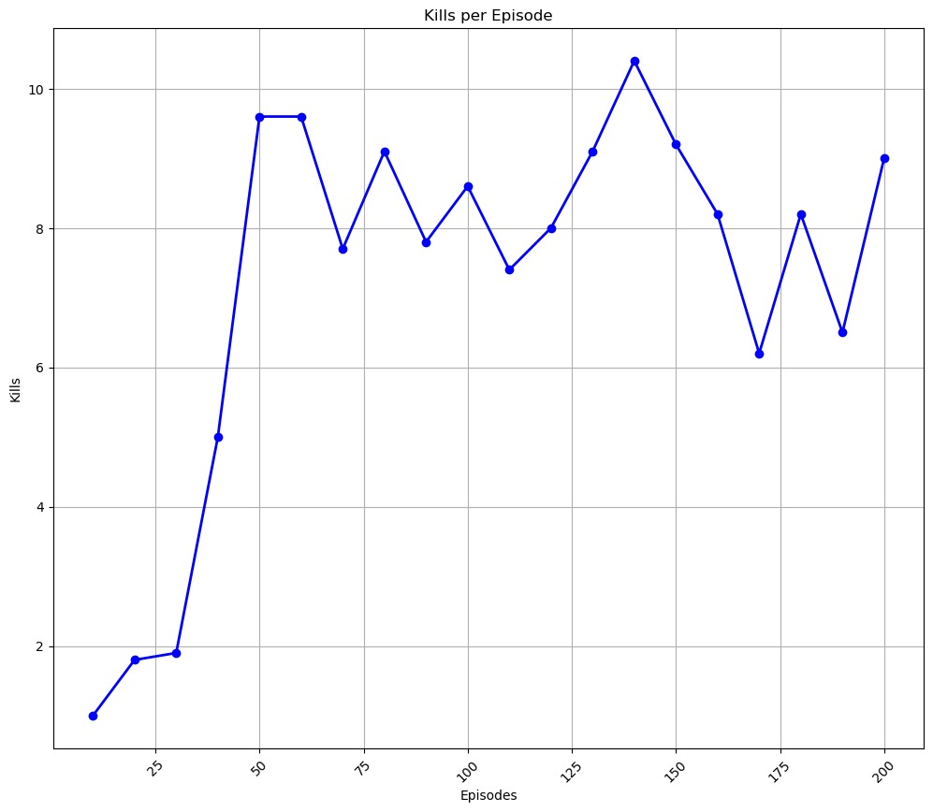
Fig. 15. Kills vs episodes graph using DDDQN in defend the center scenario.

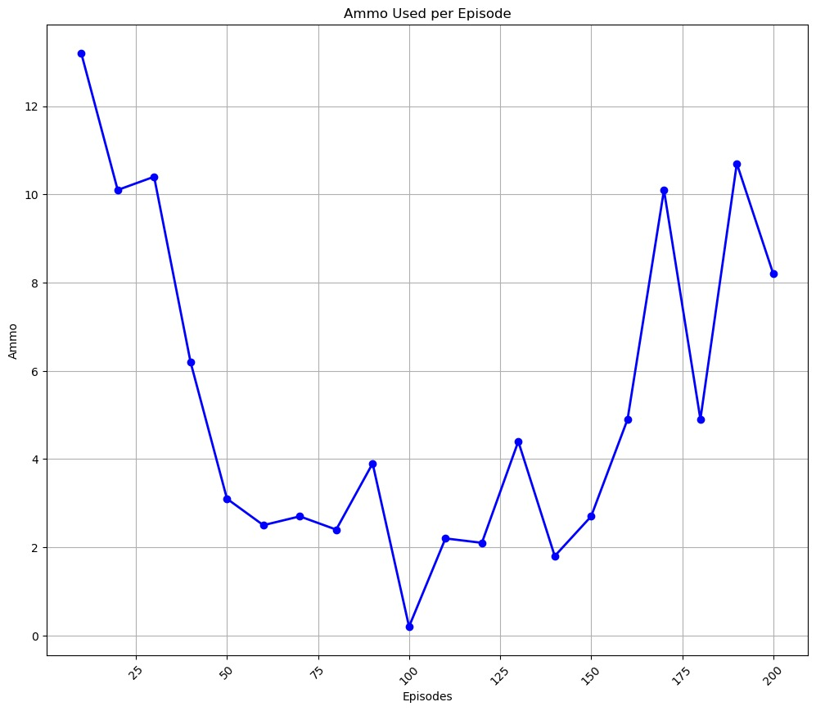
Fig. 16. Ammo vs episodes graph using DDQN in defend the center scenario.

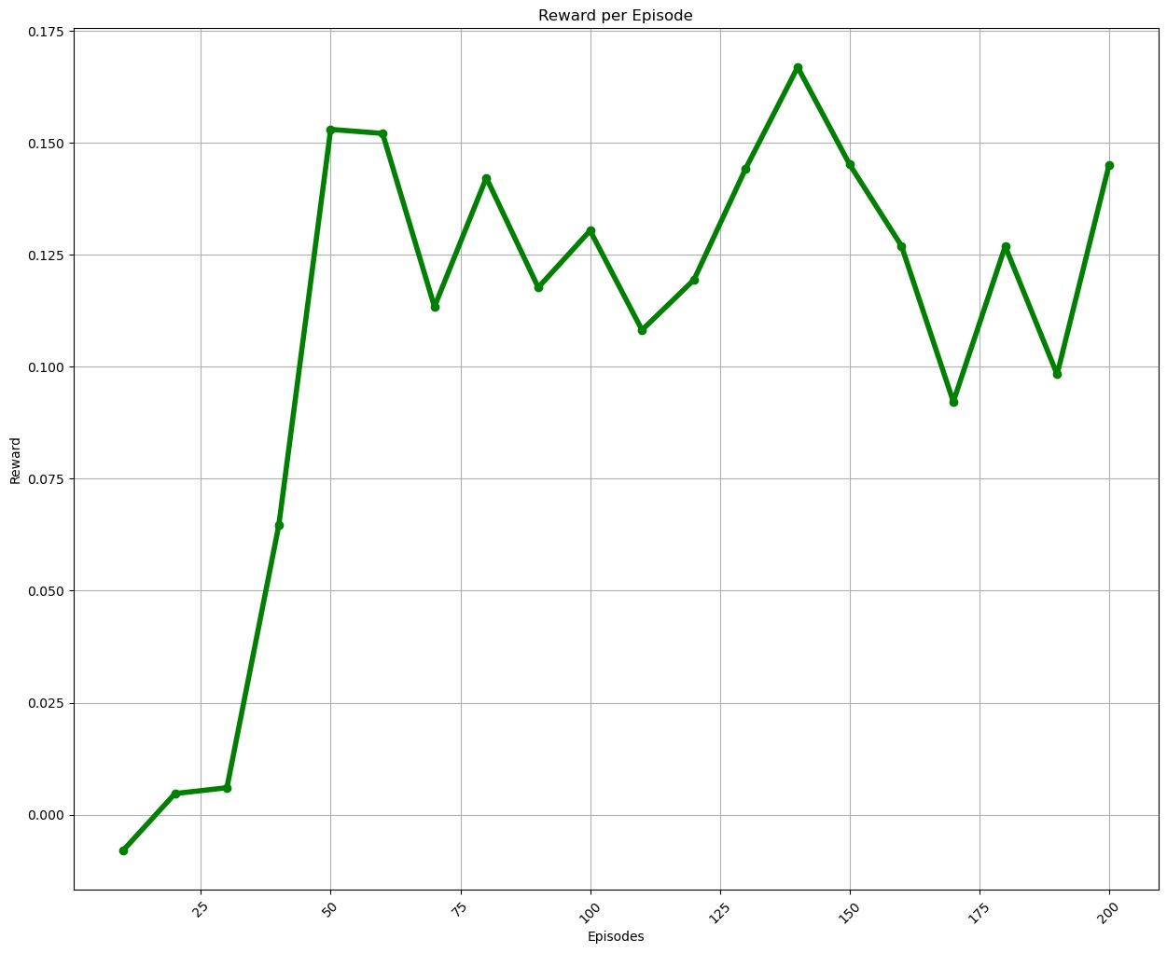
Fig. 17. Reward graph trained using DDQN in defend the center scenario.

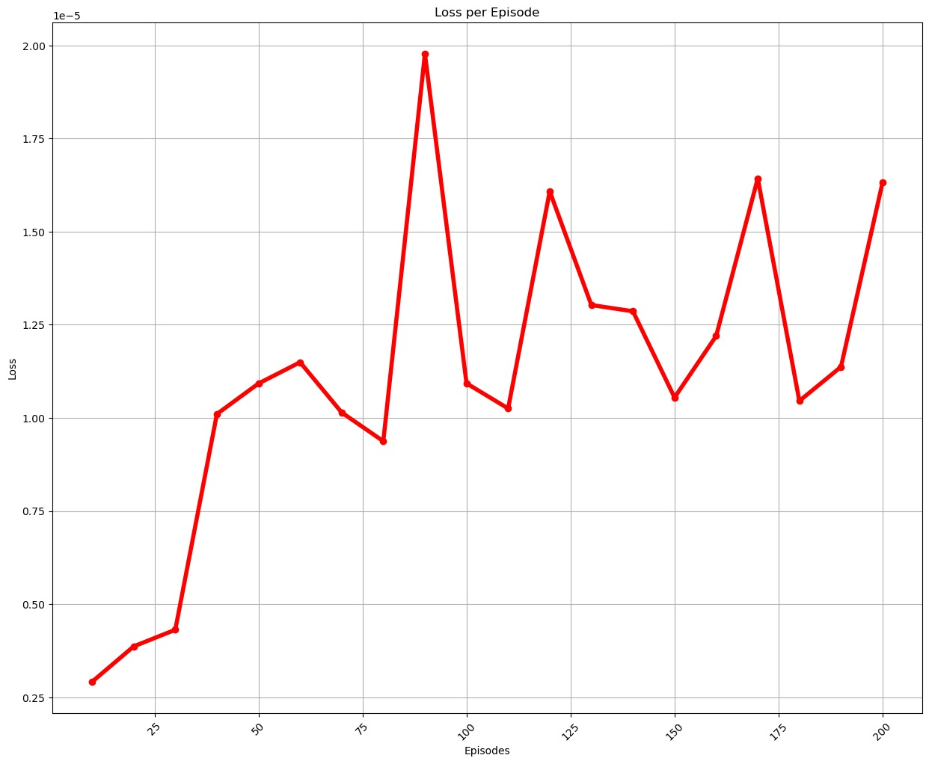
Fig. 18. Loss graph trained using DDQN in defend the center scenario.

The agent trained with the A2C algorithm exhibited a gradual improvement in performance during training. The graph shows that the agent’s performance initially remains flat at around -0.2 until 500 episodes. There is a gradual increase in the average score over episodes from 500 to 2000 episodes. Following this initial phase, the agent demonstrably improved its ability to gather health packages, as evidenced by the stepwise increase in the curve. The agent’s performance increases significantly after 2000 episodes, reaching a peak average score of about 0.8 around 2500 episodes. This trend of improvement was also observed in other performance metrics such as score, ammo remaining, and kill count, albeit with some occasional fluctuations as presented in Fig. 19, Fig. 20.

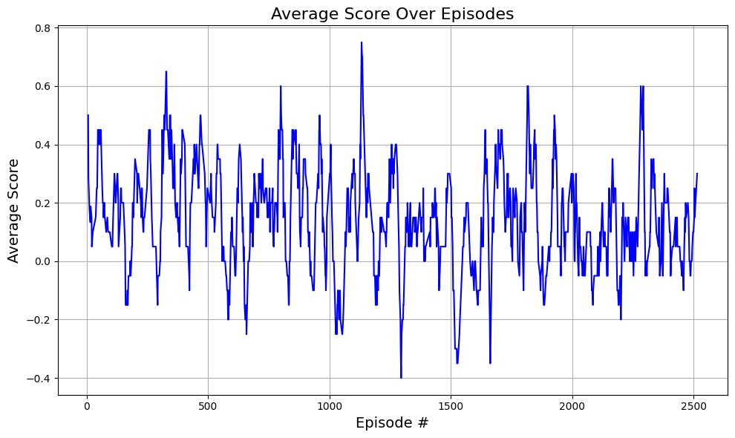
Fig.19. Average Cumulative Reward over episodes during training of agent in defend the center using A2C algorithm.

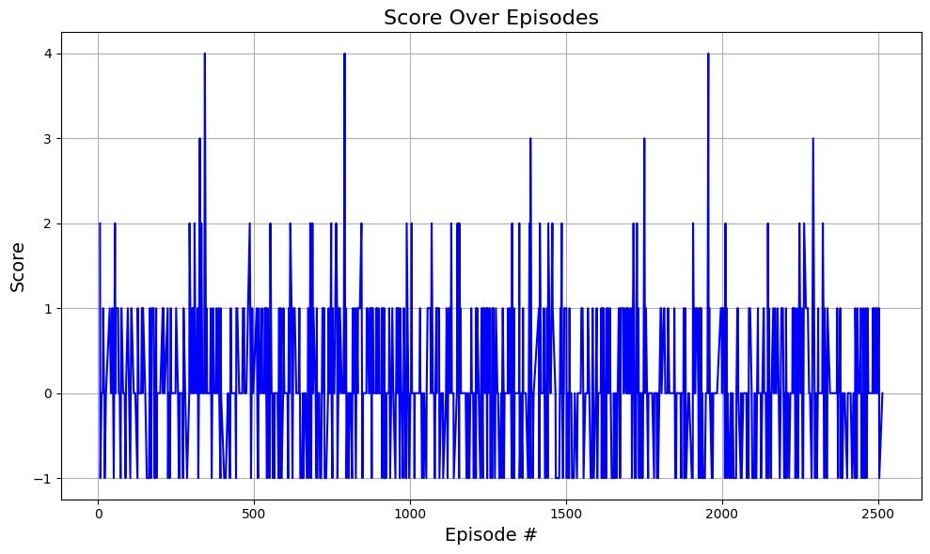
Fig.20.Total reward obtained by agent in each training episode using A2C algorithm in defend the center.

Deadly Corridor
In this section, we present the learning curves and the performance metrics of the agents trained on the 'Deadly Corridor' scenario.

Fig. 21. Kills of agent overtime stamps using PPO in deadly corridor scenario during game play.

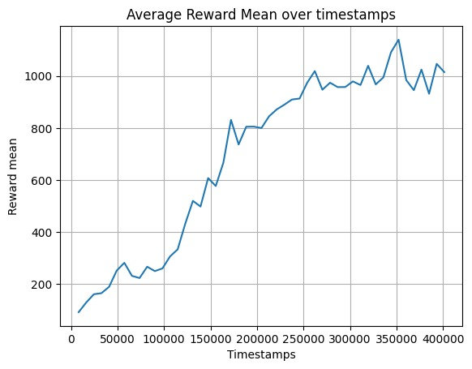
Fig. 22. Average reward graph during training using PPO in the deadly corridor scenario.

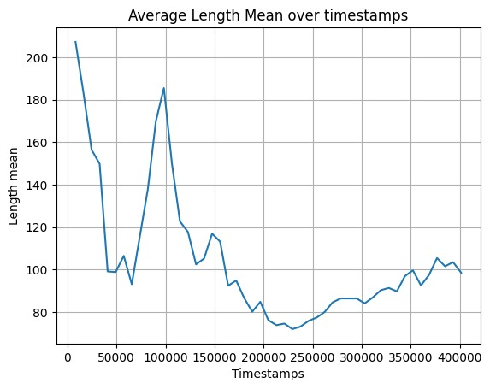
Fig. 23. Average episode length during training using PPO in deadly corridor scenario.

The agent's performance trained with the A2C algorithm is somewhat reasonable. The graphs present the average score trends of agents trained with the A2C algorithm in the deadly corridor VizDoom scenario, highlighting fluctuations and important patterns in their performance. The average score ranges from 0 to 1000 on the y-axis, with episode numbers from 0 to 5000 on the x-axis. Statistically, the average score demonstrates an overall upward trend as episodes progress, indicating continuous learning and improvement by the agents. The optimum reward achieved was 800, showing the peak performance level reached by the agents. However, there are notable fluctuations in the scores, with a significant spike down at episode 3000, suggesting a challenging phase in the agents' training. The varying distances between the blue lines on the graph emphasize performance diversity among training runs, with some consistently outperforming others. These fluctuations and patterns provide valuable insights into the effectiveness of the A2C algorithm in training agents for the deadly corridor VizDoom scenario, showcasing the learning dynamics and performance variability among the agents.

Overall, the agent gathered health with improvements steadily stepwise; at ~5000 steps, the performance arc started reaching ~71%. Likewise, the agent’s score, ammo left, and kill counts improved gradually stepwise, which is presented in Fig. 24, Fig.25.
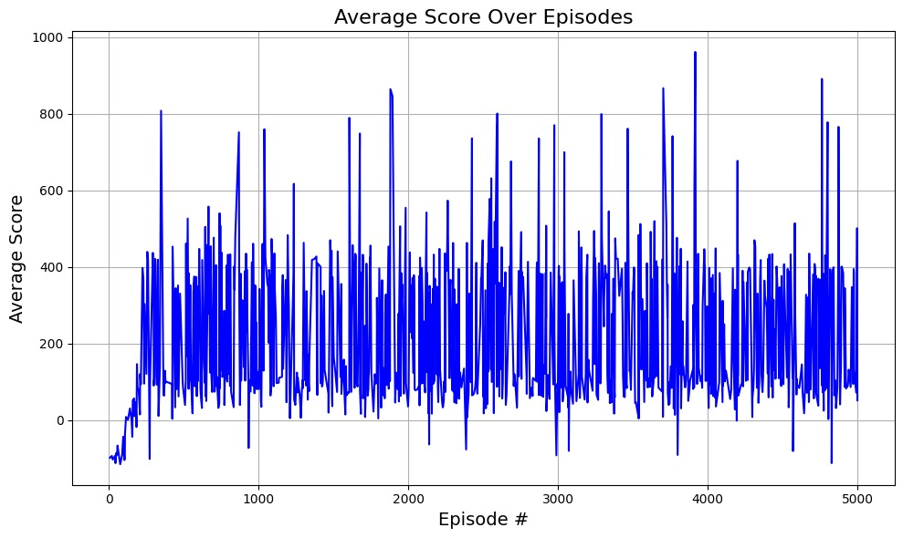
Fig.24. Average Cumulative Reward over episodes during training of agent in deadly corridor using A2C algorithm.

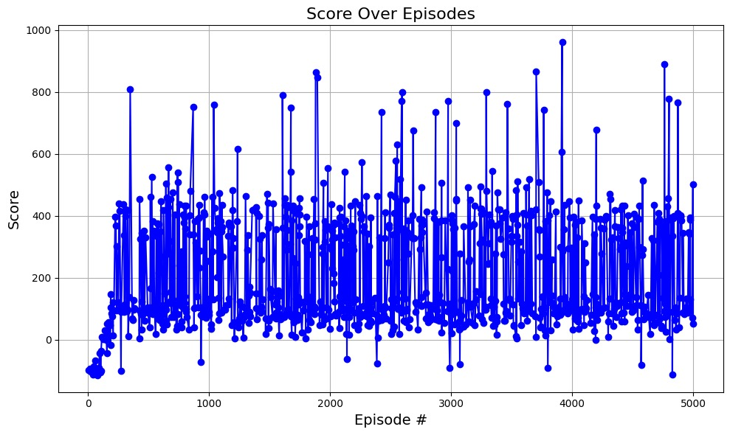
Fig.25.Total reward obtained by agent in each training episode using A2C algorithm in deadly corridor.

Basic Scenario

In this section, we present the learning curves and the performance metrics of the agents trained on the 'Basic' scenario.

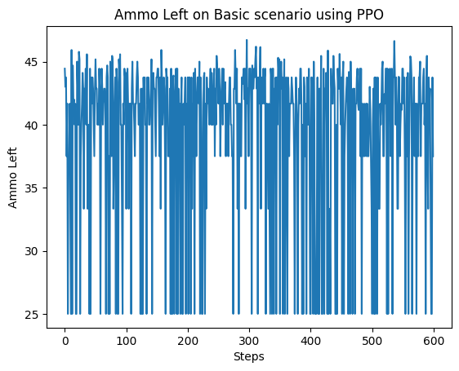
Fig. 26. Ammo left on Basic Scenario using PPO.

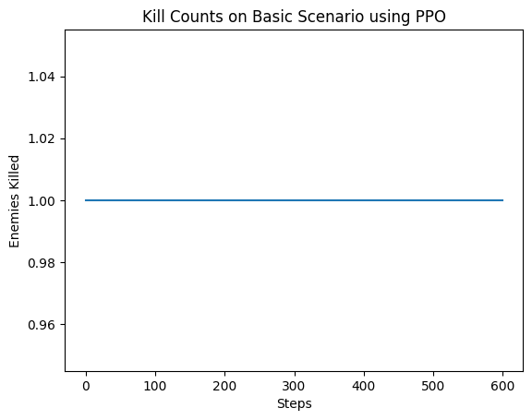
Fig. 27. Kills on basic Scenario using PPO.

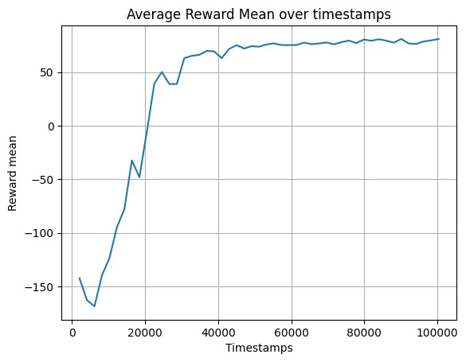
Fig. 13. Average reward graph during training using PPO in the basic Scenario.

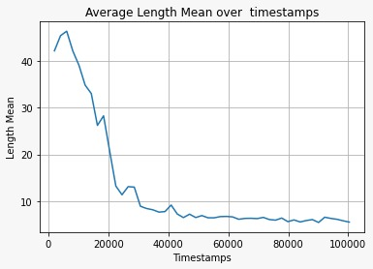
Fig. 16. Average episode length during training using PPO in basic scenario.

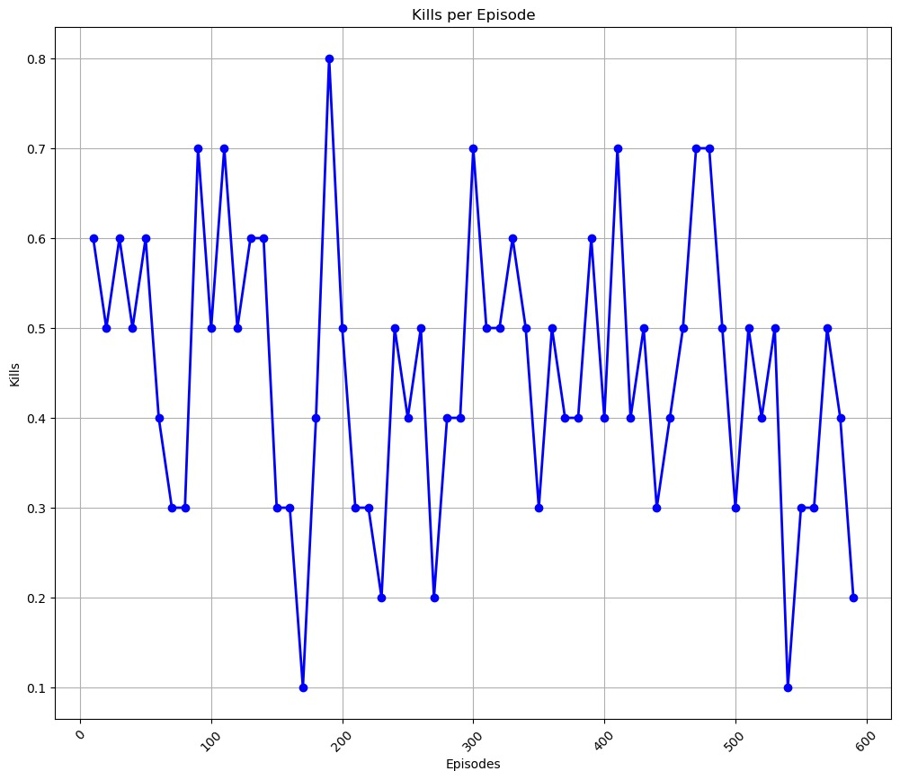
Fig. 19. Kills vs episodes graph using DDQN in basic scenario.

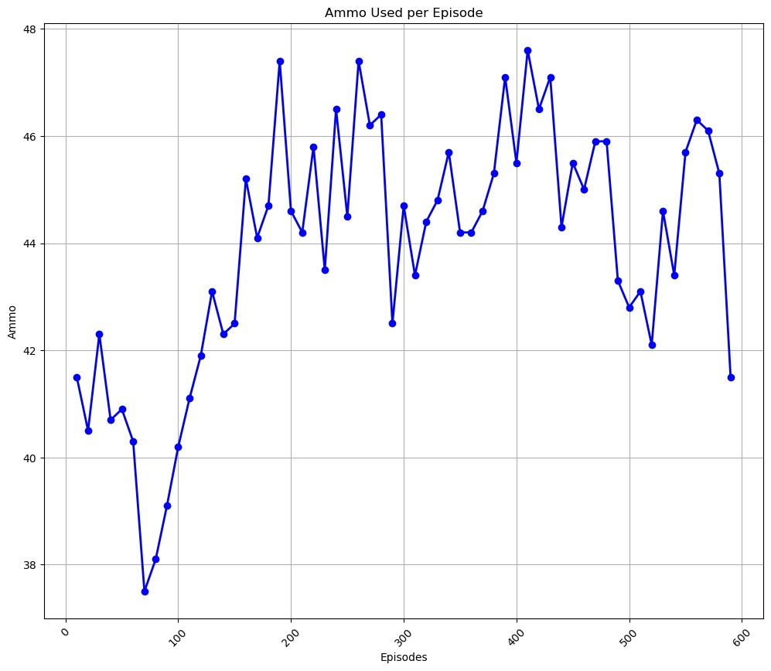
Fig. 20. Ammo vs episodes graph using DDQN in basic scenario.

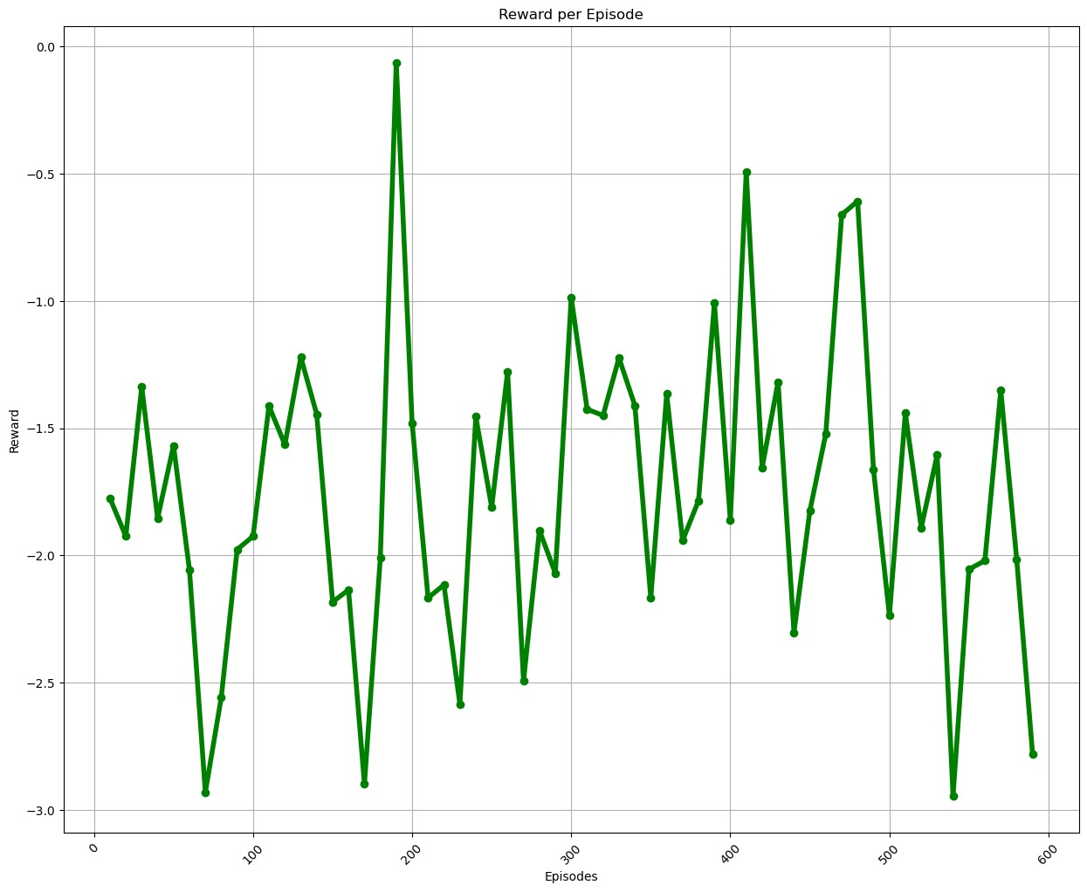
Fig. 20. Reward graph trained using DDQN in basic scenario.

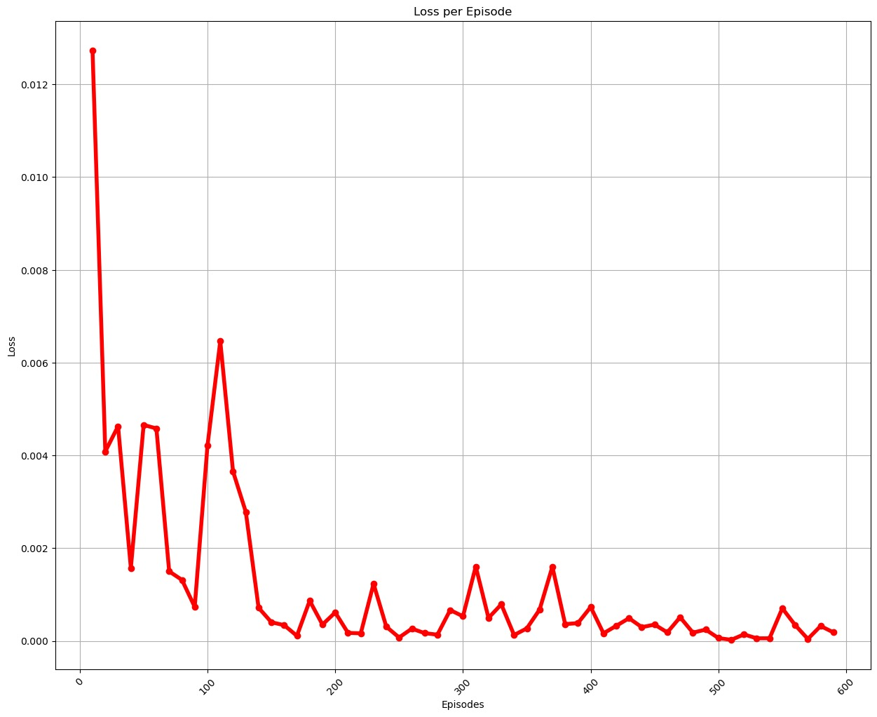
Fig. 20. Loss graph trained using DDQN in basic scenario.

Conclusion
In this project we have worked on difficult VizDoom scenarios to efficiently enhance agents’ performance. We have utilized three different reinforcement learning algorithms that include PPO, DDDQN and A2C. The scenarios include a variety of complexity levels to enhance agents’ performance, The scenarios include basic, defend the center, and deadly corridor.
Our results demonstrate how well these algorithms for reinforcement learning can handle a variety of dynamic and changing settings. Every algorithm showcased its advantages in particular situations, emphasizing how crucial it is to choose an algorithm depending on the requirements of the given task.
PPO demonstrated exceptional stability and resilience in a range of situations, and it was especially good at navigating the subtleties of simple surroundings. Its steady performance was aided by its capacity to mitigate significant policy revisions while optimizing policies.
With the addition of target networks and a dual Q-network, DDDQN performed exceptionally well in scenarios requiring strategic decision-making, like defend the center. Navigating complex circumstances required the ability to optimize the Q-value estimation and handle temporal dependencies in an efficient manner.
In addition to offering a thorough assessment of each algorithm's unique capabilities, our study's integration of various algorithms highlighted the value of algorithmic diversity in addressing a range of problems in the VizDoom context.

Future Work
The door is still open for more research as we wrap up this study. Additional research could focus on:
Algorithm Hybridization:
Investigating the possible advantages of combining parts of these algorithms into another could result in innovative solutions that, in certain cases, may even surpass separate algorithms.
Hyperparameter tuning:
Performing more thorough hyperparameter tuning for every algorithm might reveal more variations and refinements that could boost their efficiency in a variety of situations.
Scenario-Specific Tailoring:
Algorithm versatility can be gained by customizing each algorithm to a particular scenario and gaining an understanding of how adaptable it is to various environmental factors.
Real-Time Adaptation:
By putting in place mechanisms for real-time algorithm adaptation during training, agents may be better able to adjust to dynamic changes in settings, which may push the limits of their capabilities.

Transfer Learning between circumstances:
Researching the possibility of transfer learning between various circumstances may help shorten the time needed for training in unfamiliar settings and lower the amount of computer power needed to solve a variety of VizDoom scenarios.
In summary, our work advances our knowledge of reinforcement learning in complex environments and paves the way for other research projects that will continue to push the limits of agent performance in a variety of dynamic scenarios.

References:
[1] Khan, A., Shah, A. A., Khan, L., Faheem, M. R., Naeem, M., & Chang, H. T. (2024). Using VizDoom Research Platform Scenarios for Benchmarking Reinforcement Learning Algorithms in First-Person Shooter Games. IEEE Access.

[2] Asada, M., Uchibe, E., Noda, S., Tawara Sumida, S., & Hosoda, K. (1994). A vision-based reinforcement learning for coordination of soccer playing behaviors. In Proceedings of AAAI-94 Workshop on AI and A-life and Entertainment (pp. 16-21).

[3] Asada, M., Noda, S., Tawara Sumida, S., & Hosoda, K. (1996). Purposive behavior acquisition for a real robot by vision-based reinforcement learning. Machine learning, 23, 279-303.

[4] Wydmuch, M., Kempka, M., & Jankowski, W. (2018). VizDoom competitions: Playing doom from pixels. IEEE Transactions on Games, 11(3), 248-259.

[5] Geisler, B. J. (2002). An Empirical Study of Machine Learning Algorithms Applied to Modeling Player Behavior in a" First Person Shooter" Video Game (Doctoral dissertation, University of Wisconsin-Madison).

[6] Cole, N., Louis, S. J., & Miles, C. (2004, June). Using a genetic algorithm to tune first-person shooter bots. In Proceedings of the 2004 Congress on Evolutionary Computation (IEEE Cat. No. 04TH8753) (Vol. 1, pp. 139-145). IEEE.

[7] Glavin, F. G., & Madden, M. G. (2012, July). DRE-Bot: A hierarchical First-Person Shooter bot using multiple Sarsa (λ) reinforcement learners. In 2012 17th International Conference on Computer Games (CGAMES) (pp. 148-152). IEEE.

[8] McPartland, M., & Gallagher, M. (2010). Reinforcement learning in first person shooter games. IEEE Transactions on Computational Intelligence and AI in Games, 3(1), 43-56.

[9] Smith, T. C., & Miles, J. (2014). Continuous and Reinforcement Learning Methods for First-Person Shooter Games. GSTF Journal on Computing (Joc), 1(1).

[10] Jeering, A., Bein, D., & Verma, A. (2019, January). Comparison of deep reinforcement learning approaches for intelligent game playing. In 2019 IEEE 9th Annual Computing and Communication Workshop and Conference (CCWC) (pp. 0366-0371). IEEE.

[11] Shao, K., Tang, Z., Zhu, Y., Li, N., & Zhao, D. (2019). A survey of deep reinforcement learning in video games. arXiv preprint arXiv:1912.10944.

[12] Amato, C., & Shani, G. (2010, May). High-level reinforcement learning in strategy games. In AAMAS (Vol. 10, pp. 75-82).

[13] Silver, D., Schrittwieser, J., Simonyan, K., Antonoglou, I., Huang, A., Guez, A., ... & Hassabis, D. (2017). Mastering the game of go without human knowledge. nature, 550(7676), 354-359.

[14] M.N.U Islam, M. N., & Mitschele-Thiel, A. (2012, April). Reinforcement learning strategies for self-organized coverage and capacity optimization. In 2012 IEEE Wireless Communications and Networking Conference (WCNC) (pp. 2818-2823). IEEE.

[15] Moysen, J., & Giupponi, L. (2018). From 4G to 5G: Self-organized network management meets machine learning. Computer Communications, 129, 248-268.

[16] Aytar, Y., Pfaff, T., Budden, D., Paine, T., Wang, Z., & De Freitas, N. (2018). Playing hard exploration games by watching YouTube. Advances in neural information processing systems, 31.

[17] Shao, K., Zhao, D., Li, N., & Zhu, Y. (2018, August). Learning battles in VizDoom via deep reinforcement learning. In 2018 IEEE Conference on Computational Intelligence and Games (CIG) (pp. 1-4). IEEE.

[18] Mazumder, S., Liu, B., Wang, S., Zhu, Y., Liu, L., & Li, J. (2018). Action permissibility in deep reinforcement learning and application to autonomous driving. KDD'18 Deep Learning Day.

[19] Jaderberg, M., Czarnecki, W. M., Dunning, I., Marris, L., Lever, G., Castaneda, A. G., ... & Graepel, T. (2019). Human-level performance in 3D multiplayer games with population-based reinforcement learning. Science, 364(6443), 859-865.

[20] Bellemare, M. G., Naddaf, Y., Veness, J., & Bowling, M. (2013). The arcade learning environment: An evaluation platform for general agents. Journal of Artificial Intelligence Research, 47, 253-279.

[21] Johnson, M., Hofmann, K., Hutton, T., & Bignell, D. (2016, July). The Malmo Platform for Artificial Intelligence Experimentation. In Ijcai (pp. 4246-4247).

[22] Machado, M. C., Bellemare, M. G., Talvitie, E., Veness, J., Hausknecht, M., & Bowling, M. (2018). Revisiting the arcade learning environment: Evaluation protocols and open problems for general agents. Journal of Artificial Intelligence Research, 61, 523-562.

[23] Torrado, R. R., Bontrager, P., Togelius, J., Liu, J., & Perez-Liebana, D. (2018, August). Deep reinforcement learning for general video game ai. In 2018 IEEE Conference on Computational Intelligence and Games (CIG) (pp. 1-8). IEEE.

[24] Kempka, M., Wydmuch, M., Runc, G., Toczek, J., & Jackowski, W. (2016, September). VizDoom: A doom-based ai research platform for visual reinforcement learning. In 2016 IEEE conference on computational intelligence and games (CIG) (pp. 1-8). IEEE.

[25] Schulman, J., Levine, S., Abbeel, P., Jordan, M., & Moritz, P. (2015, June). Trust region policy optimization. In International conference on machine learning (pp. 1889-1897). PMLR.

[26] Khan, A., Shah, A. A., Khan, L., Faheem, M. R., Naeem, M., & Chang, H. T. (2024). Using VizDoom Research Platform Scenarios for Benchmarking Reinforcement Learning Algorithms in First-Person Shooter Games. IEEE Access.

[27] Author (02/02/2024). Visual Doom AI competition 2018 – Single Track (1)

[28] Author (02/02/2024). Visual Doom AI competition 2018 – Multi Track (2)

[29] Schulman, J., Wolski, F., Dhariwal, P., Radford, A., & Klimov, O. (2017). Proximal policy optimization algorithms. arXiv preprint arXiv:1707.06347

[30] Mehdi Boubnan and Ayman Chaouki 2018. Deep reinforcement learning applied to doom. https://github.com /boubnanm/Deep-Reinforcement-Learning-applied-to- DOOM/blob/master/Deep_reinforcement_learning_applied_to _Doom.pdf

[31] Sanghi, N., & Sanghi, N. (2021). Deep Q-Learning. Deep Reinforcement Learning with Python: With PyTorch, TensorFlow and OpenAI Gym, 155-206.
[32] M. Olsson, S. Malm, and K. Witt, ‘Evaluating the effects of hyperparameter optimization in VizDoom’, Dissertation, 2022.

[33] François-Lavet, V., Henderson, P., Islam, R., Bellemare, M. G. & Pineau, J. (2018), ‘An introduction to deep reinforcement learning’.

[34] Schulman, J., Wolski, F., Dhariwal, P., Radford, A. & Klimov, O. (2017), ‘Proximal policy optimization algorithms’.

[35] Sutton, R. S. & Barto, A. G. (2018), Reinforcement Learning: An Introduction, second edn, The MIT Press.

[36] Mnih, V., Kavukcuoglu, K., Silver, D., Graves, A., Antonoglou, I., Wierstra, D. & Riedmiller, M. (2013), ‘Playing atari with deep reinforcement learning’.

[37] Moritz, P., Nishihara, R., Wang, S., Tumanov, A., Liaw, R., Liang, E., Elibol, M., Yang, Z., Paul, W., Jordan, M. I. & Stoica, I. (2017), ‘Ray: A distributed framework for emerging ai applications’.

[38] Akiba, T., Sano, S., Yanase, T., Ohta, T. & Koyama, M. (2019), Optuna: A next-generation hyperparameter optimization framework, in ‘Proceedings of the 25th ACM SIGKDD International Conference on Knowledge Discovery and Data Mining’, KDD ’19, Association for Computing Machinery, New York, NY, USA, p. 2623–2631.

[39] S. Albawi, T. A. M. & Al-Zawi, S. (2017), ‘Understanding of a convolutional neural network’.

[40] Mnih, V., Badia, A. P., Mirza, M., Graves, A., Lillicrap, T. P., Harley, T., Silver, D. & Kavukcuoglu, K. (2016), ‘Asynchronous methods for deep reinforcement learning’.

[41] Brockman, G., Cheung, V., Pettersson, L., Schneider, J., Schulman, J., Tang, J. & Zaremba, W. (2016), ‘Openai gym’.

[42] I. Grondman, L. Busoniu, G. A. Lopes, and R. Babuska, "A survey of actor-critic reinforcement learning: Standard and natural policy gradients," IEEE Transactions on Systems, Man, and Cybernetics, Part C (Applications and Reviews), vol. 42, no. 6, pp. 1291-1307, 2012.

[43] M. Hausknecht and P. Stone, "Deep recurrent q-learning for partially observable mdps," CoRR, abs/1507.06527, 2015.

[44] L. P. Kaelbling, M. L. Littman, and A. W. Moore, "Reinforcement learning: A survey," Journal of Artificial Intelligence Research, vol. 4, pp. 237-285, 1996.

